**EMPOWERING STUDENT ORGANIZATIONS: A COMPREHENSIVE CASE STUDY   
ON BUILDING AN EFFICIENT ORGANIZATION MANAGEMENT SYSTEM**

A proposed database system in Partial Fulfillment   
of Requirement in Information Management

**Submitted by:**

Ayacocho, Kylie Ross

Dimasacat, Andronicus R.

Galope, Jhean Khendrick C.

Go, Christian Harrel Y.

Naoe, Adrian B.

Odrunia, Mark Ryan J.

**July 2023**

# Background of the Study

An organization is more than just a social unit of individuals. It is a dynamic entity that is purposefully structured and managed to fulfill specific needs and achieve collective goals. Within this management structure, relationships between various activities and members are carefully established, ensuring seamless coordination of efforts. The organization further sub-divides and assigns roles, responsibilities, and authority to enable the execution of diverse tasks. As open systems, organizations not only influence their surroundings but also adapt and respond to the external environment.

Organizations inside Polytechnic University of the Philippines - Taguig (PUPT) campus play a crucial role in enriching the overall student experience and fostering personal growth. These organizations are social units of students that are structured and managed to meet various needs and pursue collective goals. They provide students with opportunities to explore their interests, develop leadership skills, and engage in extracurricular activities beyond their academic pursuits. PUP Taguig is home to a vibrant and diverse student community, with a total of 14 registered student organizations. Among these organizations, 9 are dedicated to academic pursuits, while 5 are non-academic, covering a wide range of interests and passions.

The current process utilized for managing student organizations at the Polytechnic University of the Philippines - Taguig faces various issues that hinder efficient organization management and student engagement. One of the major problems is the outdated and highly inefficient method of retrieving student information for members of an organization. The reliance on manual and traditional methods, coupled with the lack of a centralized information management system, leads to time-consuming procedures and inconsistent data. While some digital tools like Google Forms and Sheets are used to some extent, they are not integrated into a comprehensive system, resulting in a lack of real-time information and security concerns during elections. Additionally, face-to-face events require students to fill up several papers, and announcements on Facebook are not always effective in reaching all members. Overall, the current system lacks the necessary features and functionalities to simplify and automate student-related processes, affecting the overall efficiency and effectiveness of student management at PUP Taguig.

The goal of this study is to propose a comprehensive database system that optimizes the management of student organizations at Polytechnic University of the Philippines - Taguig. The objective is to enhance student participation and engagement within the campus community by streamlining organization management processes. By creating an organization management system that facilitates effective communication and coordination among members, as well as provides tools for conducting elections, event planning, and monitoring organization performance, the proposed database aims to address the existing inefficiencies and challenges faced by the current system. Through this optimization, student leaders and members will have access to a centralized and secure platform for retrieving student information, managing events, conducting elections, and sharing announcements in real-time. The ultimate goal is to empower student organizations, foster a vibrant and dynamic campus community, and promote a more efficient and effective management system for the benefit of all stakeholders at PUP Taguig.

# Statement of the Problem

The current process utilized for retrieving student information for members of an organization at the Polytechnic University of the Philippines - Taguig has become outdated and highly inefficient, as it relies on manual and traditional methods. Even though they use digital tools like Google Forms and Sheets to some extent, the PUP - Taguig organization regrettably lacks a proper system to speed up the process of obtaining student information. This reliance on manual methods and the absence of a comprehensive information management system results in time-consuming procedures and a lack of centralized and secure data.

Moreover, during face-to-face events, organizations require students to fill up several papers, and they use Excel files to gather information. Voting security during elections is also a concern when using Google Forms. Event announcements on Facebook are not always effective in reaching all members. The approach has flaws in key features and functionalities that are required to simplify and automate several student-related processes, resulting in time-consuming manual tasks, inconsistent data, and a lack of real-time information. This outdated manual process fails to meet the evolving needs of the school administration, teachers, and parents, thereby hindering the overall efficiency and effectiveness of student management.

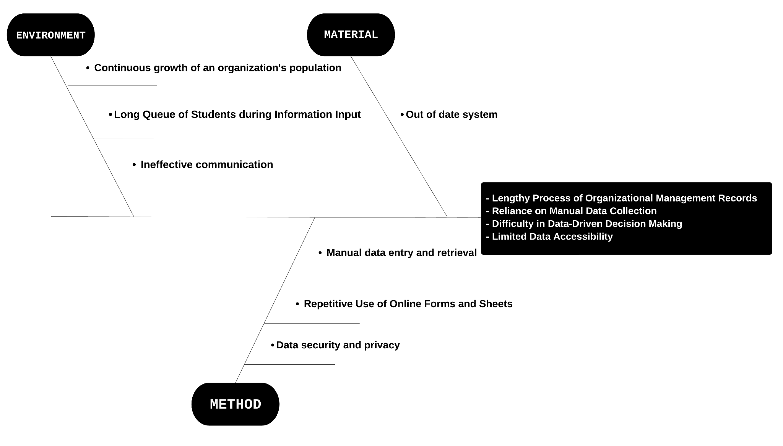

*Figure 1. Fishbone diagram that shows the issues faced by the current system*

The key problems faced by the school administration include:

* **Manual data entry and retrieval**
* The current system sometimes still relies heavily on manual data entry, leading to errors, duplication of efforts, and data inconsistencies. The lack of an automated process for data entry and retrieval not only wastes valuable time but also increases the risk of inaccuracies in student records.
* **Data security and privacy**
* The current system lacks strong data security measures, making student information vulnerable to unauthorized access and potential breaches. This poses a significant risk to the privacy of student data and raises concerns about compliance with data protection regulations.
* **Ineffective communication**
* The absence of a centralized platform for communication and collaboration between organization officer personnel and students members hampers effective coordination and timely sharing of important organization-related information. This leads to delays in addressing concerns, inefficient interactions, and an incoherent approach to student management.
* **Repetitive Use of Online Forms and Sheets**
* The practice of repeatedly creating Online forms and documents or spreadsheets for online data collection introduces inefficiencies and adds complexity to the information management process.
* **Long Queue of Students during Information Input**
* The manual process of inputting student information leads to extended waiting times and queues, negatively impacting student experience and overall operational efficiency.
* **Continuous growth of an organization's population**
  + An organization's information management system may be significantly impacted by the population's ongoing growth. Scalable infrastructure, effective data storage and retrieval, appropriate user access controls, and steps to preserve data accuracy and integrity are all necessary. By addressing these issues, the organization can ensure effective information management while giving members' privacy and security top priority through strong security measures and compliance with data protection laws.

To overcome these difficulties, an innovative, integrated student management database system that provides effective functionality, simple operations, improved communication, secure data management, and insightful reports must be put in place. Such a system would give the management of the school organization the resources and knowledge required to efficiently manage student membership records, facilitate communication, and make data-driven decisions for the overall improvement of organization information management in Polytechnic University of the Philippines – Taguig.

# Objectives

Organizations in the Polytechnic University of the Philippines—Taguig has an old-fashioned way of retrieving their student member’s information, the common way of processing student member records, and spreading out announcements and information about the events that they may conduct has become inefficient, presenting several issues that hinder their member’s experience and relationship towards the organization. The current traditional system lacks essential functionalities needed to streamline various processes causing the key problems that the current system has: Manual data entry, Data Security, Ineffective communication, Repetitive Use of Online Forms and Sheets, Long Queue of Students during Information Input and Continuous growth of organizational population. This outdated system fails to meet the needs of effective organizational management in this day and age, hindering the overall efficiency and effectiveness of the organization. The manual and conventional way of processing things is not reliable anymore because of its unproductive way of performing tasks. Technology is accessible and this proposed study has the objective to make the process more efficient, eliminate and change the contemporary way of managing an organization at our university. The problems we face on our campus regarding organizational processes are something that we can improve with the technology currently available. The indicated proposed project by our group has the main objective of creating an Organization Management System that has the capability of eliminating the prevailing issues of organizations because of their inefficient way of mandating things at the present time being.

Key areas of focus include:

**Centralized Information:**

* Centralizing Information that consolidates relevant organizational information, including student records, personal information, event types, event schedules, and other organizational academic resources.

**Automation Administrative Tasks:**

* Automation for administrative tasks such as student registration, payment fees, event reminders and other necessary applications for staff and administrative personnels.

**Enhance Communication:**

* Facilitate effective communication among members and administrators through a reliable Organization Management System that generates notifications, and announcements for important agendas or events that organization may conduct.

**Facilitate Organizational Election Services:**

* An efficient and well-functional system that manages organizational election services, and academic support programs such as academic events which are relevant for students’ overall well-being.

**Improve Student Experience:**

* Automating a system improves the service by providing quicker response times, accurate information, and smooth processes than the traditional way.

# Areas of Consideration

**A. Internal Factors**

**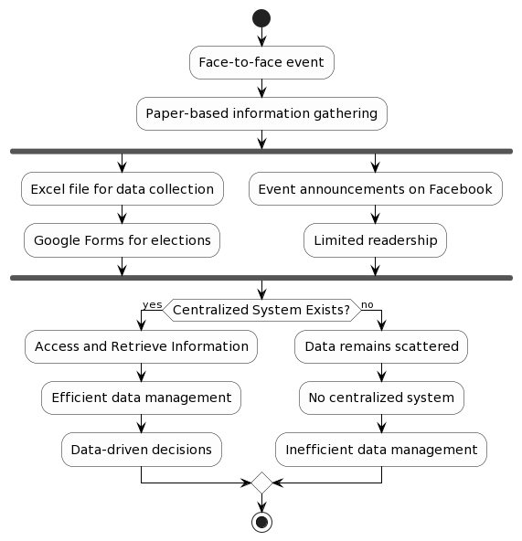***Figure 2. Activity Diagram that shows the state of the current system*

1. **Processes**

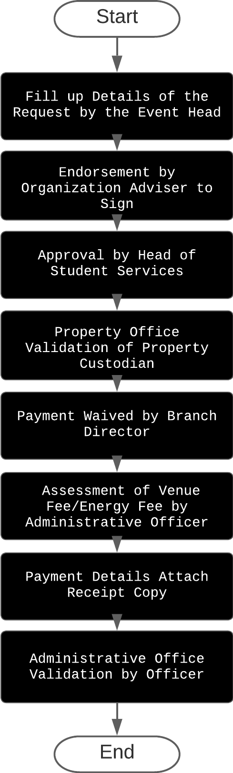

*Figure 3. A flowchart that shows the process of the current system*

* The current systems employed at Polytechnic University of the Philippines — Taguig follow a rather traditional approach. Initially, data gathering is carried out manually, with information being recorded in spreadsheets. Subsequently, this data is transferred to the system database. While this process may have sufficed in the past, it is time-consuming and susceptible to errors, potentially leading to inaccuracies in the final records. To be able to conduct events of every organization, they need to submit a GPOA (Plan events for every semester) to validate the events if it is accepted to conduct. Next, when every event date is up ahead, the organization officers need to submit a letter for approval to the organization adviser then it will be sent to the head of student service.

1. **Operations**

* As for the operation of communication and updates, the university relies heavily on social media platforms such as Facebook and Twitter. While these platforms offer a convenient way to reach both members and non-members of the institution, they may not be the most reliable or comprehensive means of communication. The fast-paced nature of social media could lead to important announcements being overlooked or missed by the intended recipients.

**Strength:**

Strength of these traditional systems are making it easy to implement, have basic functionalities, spreadsheet database for easy access to member records, reporting for organization is easy, and the system may have a user-friendly interface that is easy to navigate and understand.

**Weakness:**

While the weaknesses are gathering data is slow, inadequate scalability to accommodate a growing membership base, the systems are slow due to too much data recorded, inefficiencies in data entry and retrieval processes, insufficient data analysis and reporting capabilities.

**B. External Factors**

1. **Demographic**

* The current management system at Polytechnic University of the Philippines - Taguig might use some work. First, we need to automate data management so that student records may be entered and retrieved more quickly and accurately. The second issue is the repetition of data in each row when new data is input. To minimize redundancies and maintain data correctness, it must create a more simplified data entry method. Third, the organization's communication mechanism needs to be improved. Lastly, the current system lacks scalability, making it difficult to meet the university's expanding needs. Faculty, students, and organization officers all use the current management system. Faculty members used the system to double-check student information, enter certain private data, and collect finalize data. Students only used this system to gather raw data, whereas the organization officers, who are students from various organizations with different positions, used it to sort the data, enter some data, give access to the students when it needed to gather information, and send the sorted information to the professors and faculty members.

1. **Technology**

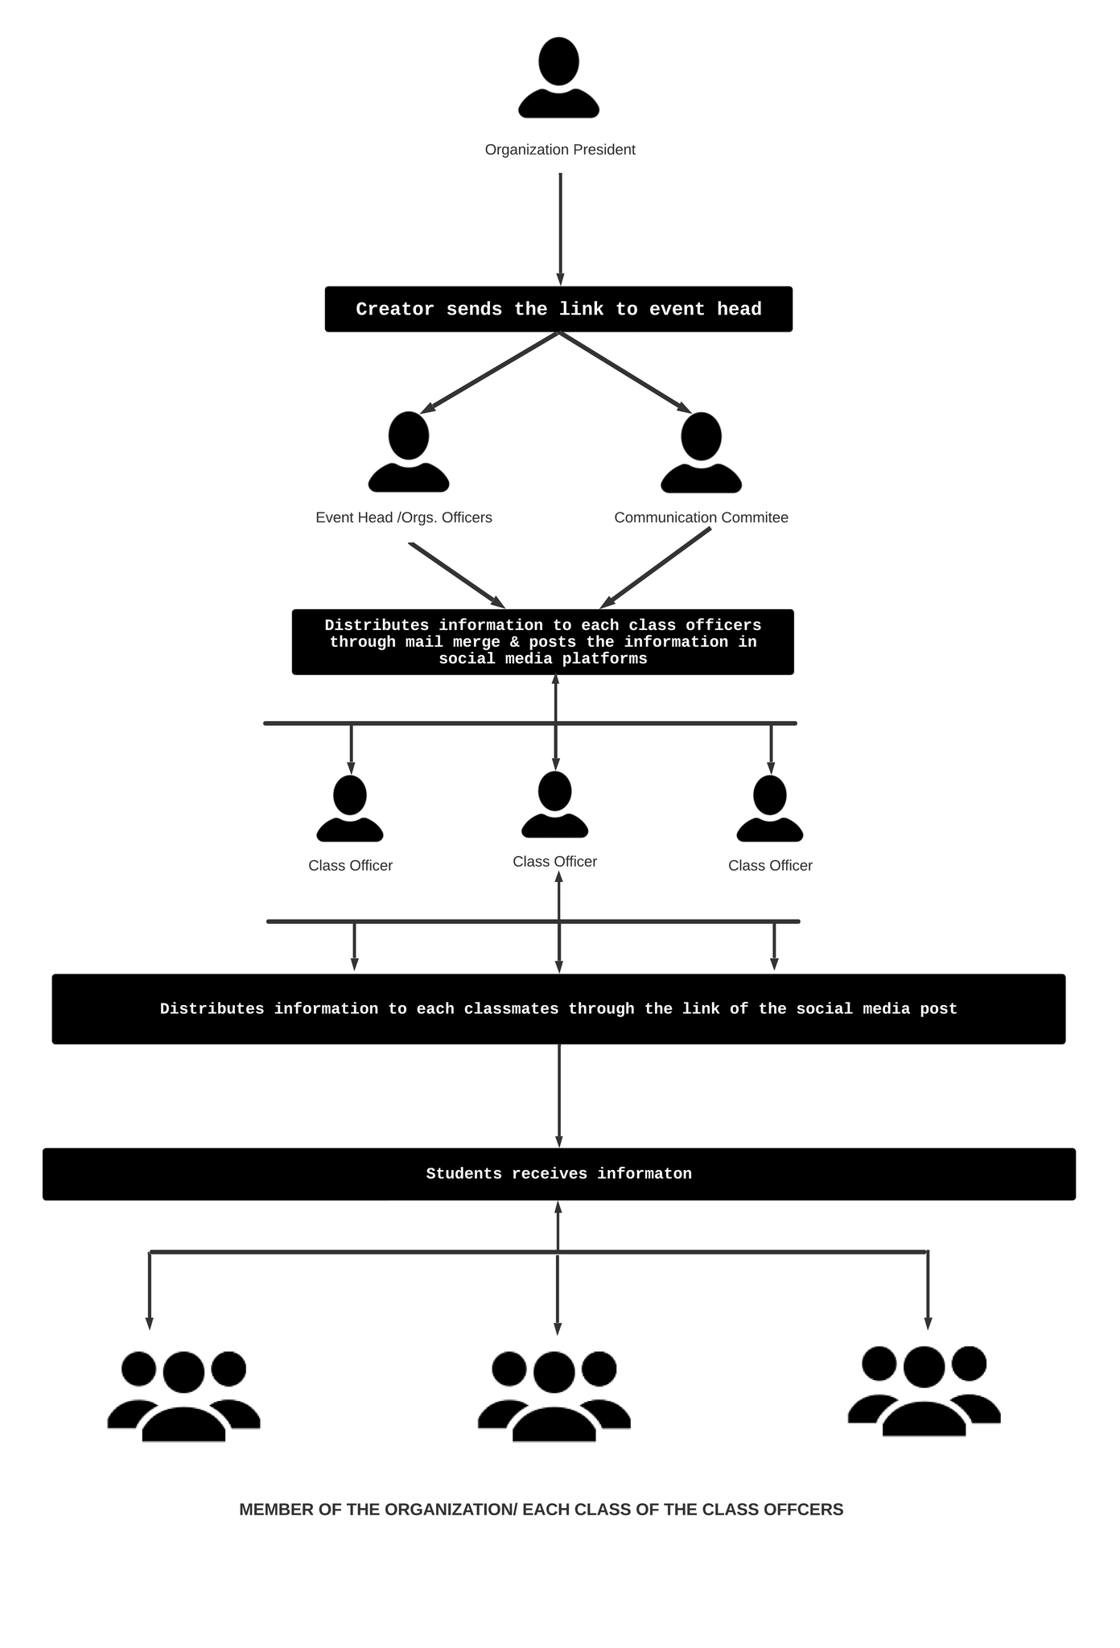

*Figure 4. Architecture Diagram that shows the process of how the user access the system*

* The existing system for organization. Student records for current members are primarily kept on spreadsheets, making them less secure. They use mail merge in emails to invite members of the organization to special events and activities. They use social media platforms such as Facebook and Twitter to provide updates. It needs to enhance all of these to become more smooth, efficient, and secure when it comes to managing organizations like making specific systems.

**Opportunities:**

The PUPSIS platform is one of the most frequent platforms at Polytechnic University of the Philippines, where students can check the curriculum evaluation, enroll in particular courses, and so on. So, in essence, this system contains all of the student information. We can improve this system even further by incorporating organizational data. It can tell and distribute them to their particular organization through the courses they apply, which means it is automatically a member of the organization that they represent. Of course, they must first apply to the University and be accepted as a student before they may receive their personal PUPSIS account. The system for this is the PUP iApply. By completing the system application form. The University can already collect information. So, if a specific student passes, the data in iApply can be transferred to PUPSIS.

**Threats:**

The current systems at Polytechnic University of the Philippines - Taguig are confronted with various critical threats that require immediate attention. The most pressing issue is the system's lack of security, which exposes sensitive data to potential leaks and unauthorized access, potentially leading to data breaches and identity theft. Additionally, the repetition of data for each entry further endangers data accuracy and efficiency, potentially resulting in inconsistencies and hindering decision-making processes. Furthermore, relying on social media platforms and spreadsheets for communication and record-keeping exposes the university to privacy and security risks, enabling unauthorized access and dissemination of misinformation. Lastly, the system's limited scalability could hinder the university's ability to meet its expanding needs, causing performance problems and service disruptions.

Considering these internal and external factors, it is evident that an enhanced and integrated web-based organization membership information system is necessary to address the weaknesses of the current system and leverage the opportunities presented by changing demographics and technology advancements.

# Conclusion

Our case study titled "Empowering Student Organizations: A Comprehensive Case Study on Building an Efficient Organization Management System" addresses the pressing issues faced by student organizations at the Polytechnic University of the Philippines—Taguig due to their outdated and inefficient methods of managing information and organizational processes. The primary objective of this study was to design and implement a modern and efficient Organization Management System to streamline various processes and overcome the key problems hindering the overall effectiveness of these organizations.

The existing manual and conventional system have proven to be time-consuming, error-prone, and ineffective in handling the growing needs of student organizations. Through our project, we identified critical internal factors, including slow data gathering, inefficiencies in data entry and retrieval, and insufficient scalability, as well as external factors like the reliance on social media platforms for communication and potential privacy risks.

In response to the areas of consideration, we recommend the implementation of an enhanced and integrated web-based Organization Management System. This proposed system aims to centralize information, automate administrative tasks, enhance communication, and facilitate organizational election services. By creating a centralized database and automating routine tasks, the system will promote efficiency, accuracy, and transparency while reducing manual efforts and potential errors.

Enhanced communication features, such as timely notifications and announcements, will foster better collaboration among members and administrators, reducing misunderstandings and keeping everyone well-informed and engaged. Additionally, the system will ease the election process, ensuring fairness and accessibility for all members, and contribute to students' growth through improved academic event organization.

Considering the identified internal and external factors, the proposed Organization Management System has the potential to innovate student organizations, empowering them to become more efficient, transparent, and collaborative entities. Leveraging technology and addressing current shortcomings, our solution directly addresses the challenges and weaknesses faced by the current system.

To ensure a successful transition and maximize the benefits of the proposed system, it is crucial to prioritize its implementation, tailoring it to the specific needs of the Polytechnic University of the Philippines—Taguig's student organizations. By doing so, we can pave the way for a thriving organizational culture, where members and administrators can work together seamlessly and effectively.

The proposed Organization Management System represents a significant step towards modernizing and optimizing student organizations' operations. It is our belief that with the right technology and strategic approach, these organizations can reach new heights of efficiency, collaboration, and success. By embracing this system, the Polytechnic University of the Philippines—Taguig can empower its student organizations to thrive in the ever-changing landscape of higher education.

# Recommendations

Based on the findings and analysis, the following recommendations are proposed. Design and implement an integrated School Organization Management System that centralizes student records, enrollment processes, grading systems, and other administrative functions. Develop a user-friendly interface for students, faculty, and administrators to access and manage organization information efficiently. Provide training and support for the university staff to ensure a smooth transition and adoption of the new system. Regularly monitor and evaluate the performance and effectiveness of the implemented School Organization Management System to address any emerging issues and make necessary improvements. Incorporate communication tools, such as messaging systems or announcement features, to augment communication between students and faculty members. Implement mechanisms to gather user feedback and suggestions pertaining to the School Organization Management System. Consistently assess the received feedback to integrate new and better updates to the system. Recommend the implementation of the new School Organization Management System for all branches of the Polytechnic University of the Philippines. Following are the modules of the proposed system:

* **Login Module:** This module allows users to securely log in to the system, providing access to personalized information based on their roles and permissions.
* **Organization Module:** This module manages information related to student organizations, including their profiles, objectives, and activities.
* **Organization Members Module:** This module handles the registration and management of organization members, ensuring accurate and up-to-date membership records.
* **Election/Voting Module:** This module facilitates the conduct of elections, enabling eligible members to vote for candidates running for various positions within the organizations.
* **Events & Announcement Module:** This module oversees the planning and coordination of events and announcements, providing a centralized platform for sharing important information.

# Proposed Process Flow

In the old system, students had to manually fill out paper-based forms and spreadsheets online, wait in physical queues for data input, and rely on inconsistent data management due to the lack of automation and real-time updates, leading to inefficient communication and potential data security risks. This study proposes several new processes:

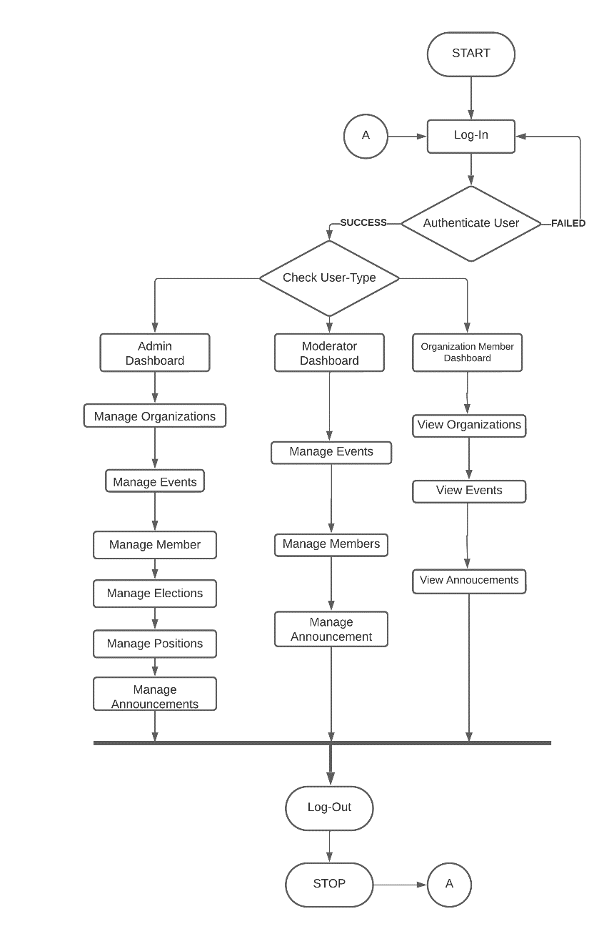

*Figure 5. Flowchart that shows the proposed process flow of the system*

The proposed flowchart represents the user login and dashboard navigation process. When a user attempts to log in, the system checks the provided credentials against the database. If the login is successful, the flow moves forward, but if it fails, the user is prompted to log in again until successful.

After successful login, the system checks the user's type (admin, moderator, or organization member) to determine their privileges. If the user is an admin, they gain access to the Admin Dashboard, enabling them to manage organizations, events, members, elections, positions, and announcements. If the user is a moderator, they gain access to the Moderator Dashboard, where they can manage events, members, and announcements. Lastly, if the user is an organization member, they are directed to the Member Dashboard, granting them access to view organizations, events, and announcements.

This role-based access control ensures that users can only access functionalities appropriate for their roles, enhancing security and user experience. The flowchart streamlines the user journey, directing them to their designated dashboard, tailored to their specific responsibilities within the system.

# Database Design

# 

*Figure 6. Database schema that shows the entire database structure*

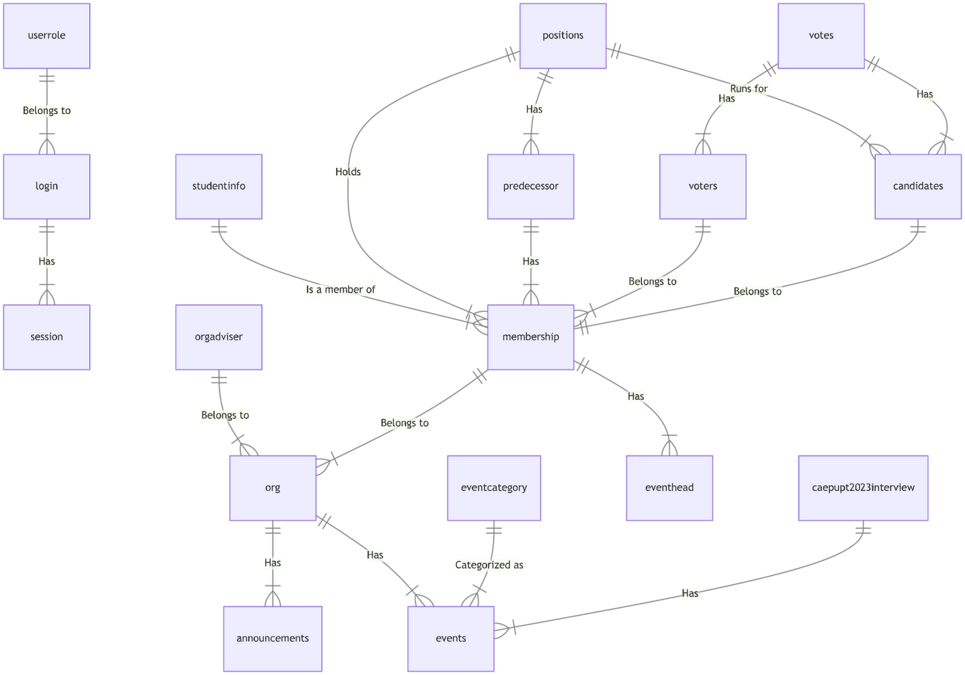

*Figure 7. ER diagram of the proposed system*

The proposed Database Design comprises several tables interconnected through meaningful relationships, contributing to the efficiency and organization of the system.

* The **tbl_userrole** table represents various user roles in the system, such as admin, moderator, or member. It is connected to **tbl_login**, which stores user login information, indicating that each login entry "belongs to" a specific user role defined in tbl_userrole. This relationship is crucial for the system to differentiate between different user types and grant appropriate access and permissions.
* The **tbl_login** table is associated with **tbl_session**, which represents user sessions or activities. This relationship signifies that each session "has" a specific login entry linked to it, enabling the system to track user activities and manage user sessions effectively.
* The **tbl_orgadviser** table contains advisers or mentors associated with organizations, while **tbl_org** represents the organizations in the system. Each orgadviser "belongs to" a specific organization defined in tbl_org, allowing organizations to have designated advisers providing guidance and support.
* The **tbl_studentinfo** table holds student information, and **tbl_membership** represents membership status in organizations. Each membership entry "is a member of" a specific student defined in tbl_studentinfo, linking students to their respective memberships in organizations.
* Similarly, **tbl_membership** "belongs to" **tbl_org**, indicating that each membership entry is associated with a particular organization defined in tbl_org. This relationship facilitates the organization and management of members based on their affiliation with different organizations.
* The **tbl_positions** table signifies various positions or roles within organizations. It is related to **tbl_membership**, indicating that each membership entry "holds" a specific position defined in tbl_positions. This assists the system in keeping track of members and their roles within organizations.
* The **tbl_predecessor** table represents former officers within organizations, connected to **tbl_membership**, showing that each predecessor entry "has" a specific membership defined in tbl_membership. This enables the system to link former members to their previous roles within organizations.
* Furthermore, **tbl_positions** is associated with **tbl_predecessor**, illustrating that each predecessor entry "has" a specific position defined in tbl_positions. This relationship aids in recording the positions held by former officers.
* The **tbl_voters** table comprises members eligible to vote in elections, and **tbl_membership** signifies membership status in organizations. Each voter "belongs to" a specific membership defined in tbl_membership, helping the system identify members eligible to participate in elections.
* Similarly, **tbl_candidates** table consists of candidates running for positions in elections, connected to **tbl_membership**, indicating that each candidate "belongs to" a specific membership defined in tbl_membership. This assists in identifying members running for different positions.
* Additionally, **tbl_positions** "runs for" **tbl_candidates**, signifying that each candidate is running for a specific position defined in tbl_positions. This links candidates to the positions they are vying for.
* The **tbl_votes** table records votes cast by voters in elections. It is connected to both **tbl_voters** and **tbl_candidates**, illustrating that each vote "has" a specific voter from tbl_voters and a specific candidate from tbl_candidates. This relationship links votes to the members who cast them and the candidates they voted for.
* Moreover, **tbl_org** "has" **tbl_events**, indicating that each event is associated with a specific organization defined in tbl_org. This allows the system to organize events based on their organizing organizations.
* The **tbl_eventcategory** table categorizes different types of events, and **tbl_events** "categorized as" tbl_eventcategory, signifying that each event is classified under a specific event category. This aids in organizing events based on their types.
* Additionally, **tbl_membership** "has" **tbl_eventhead**, representing that each eventhead is associated with a specific membership defined in tbl_membership. This enables the system to link event organizers to their respective memberships in organizations.
* Furthermore, **tbl_caepupt2023interview** contains volunteers assigned to help the interviewee, and **tbl_events** "has" tbl_caepupt2023interview, signifying that each interview assignment is related to a specific event from tbl_events. This association allows the system to manage interview tasks in relation to the events they are assigned to.
* Lastly, **tbl_org** "has" **tbl_announcements**, indicating that each announcement is associated with a specific organization defined in tbl_org. This helps the system link announcements to the organizations that made them.

The proposed Database Design provides a comprehensive visual representation of the database, showcasing the relationships between different entities and their connections. This facilitates efficient data management, organization, and access control within the proposed organization system, ultimately contributing to its smooth operation and effectiveness.

# Login Module

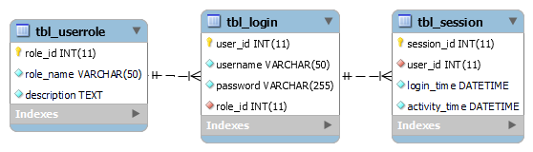

*Figure 8. Login Module of the proposed system*

The Login Module is a crucial component of the system, it is responsible for facilitating secure user authentication and access control. It ensures that only authorized users can access specific functionalities based on their assigned roles.

1. **tbl_userrole:**

* Purpose: tbl_userrole defines different user roles in the system, such as admin, moderator, or member. Each role has specific access privileges and permissions associated with it.
* Relationship: tbl_userrole is connected to tbl_login through the role_id foreign key. This relationship allows the system to assign a specific role to each user during the login process.

1. **tbl_login:**

* Purpose: tbl_login stores user login information, including usernames, hashed passwords, and their associated user roles. It ensures the security of user credentials.
* Relationship: tbl_login is linked to tbl_userrole through the role_id foreign key, enabling the system to map each user's login credentials to their assigned user role.

1. **tbl_session:**

* Purpose: tbl_session keeps track of user sessions or activities, including login and logout timestamps. It helps manage active user sessions and track user interactions within the system.
* Relationship: tbl_session is associated with tbl_login through the user_id foreign key. This connection allows the system to link user sessions to their respective login entries, ensuring session management and activity tracking.

# Organization Module

*Figure 9. Organization Module of the proposed system*

The Organization Module is responsible for managing information related to various organizations within the system. It allows the user, depending on their role to create, view, and update organization details, including adviser information.

1. **tbl_org:**

* Purpose: tbl_org serves as the central table for storing organization data. It contains essential information about each organization, such as org_id (unique identifier), org_name, description, year_started, and status. This table provides an overview of all the registered organizations in the system.
* Relationship: tbl_org is related to tbl_orgadviser through the org_id foreign key. This association enables the system to link an adviser to the corresponding organization they handle.

1. **tbl_orgadviser:**

* Purpose: tbl_orgadviser stores data about organization advisers. It includes details like adviser_id (unique identifier), org_id (foreign key), adviser_name, and adviser_email. This table helps in tracking and managing advisers associated with different organizations.
* Relationship: tbl_orgadviser is connected to tbl_org through the org_id foreign key. This relationship allows the system to link an adviser to a specific organization in tbl_org.

# Organization Members Module

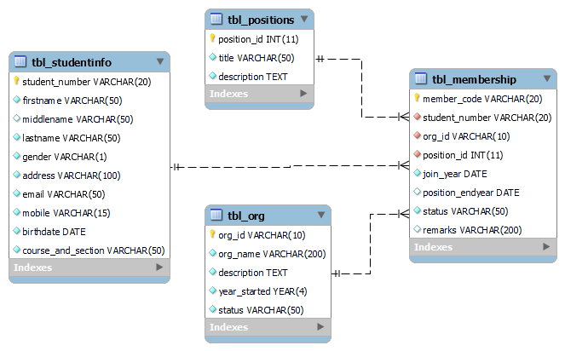

*Figure 10. Organization Members Module of the proposed system*

The Organization Members Module is responsible for managing the membership details of individual students in different organizations and their respective positions.

1. **tbl_studentinfo:**

* Purpose: tbl_studentinfo is a vital table in the Organization Members Module, responsible for storing detailed information about individual students who are members of different organizations. It contains attributes such as student_number (primary key), firstname, middlename, lastname, gender, address, email, mobile, birthdate, and course_and_section. This table serves as a repository for student-specific data, including personal information and contact details, which are essential for managing organization memberships and facilitating communication with members.
* Relationship: tbl_studentinfo is connected to tbl_membership through the student_number foreign key. This relationship allows the system to link each student with their respective organization memberships. By establishing this connection, the system can easily determine the members associated with each organization and access their individual student information.

1. **tbl_positions:**

* Purpose: tbl_positions stores data related to different positions or roles within organizations. The table includes attributes such as position_id (primary key), title, and description. This table serves as a reference for all available positions that members can hold within organizations, such as president, vice president - internal, treasurer, etc. It provides a standardized list of positions to ensure consistency and clarity in organizational roles.
* Relationship: tbl_positions is related to tbl_membership through the position_id foreign key. This relationship enables the system to associate each organization member with their respective position within the organization. By linking members to specific positions, the system can determine the organizational structure and the roles held by different members.

1. **tbl_membership:**

* Purpose: tbl_membership represents the core of the Organization Members Module. It contains attributes such as member_code (primary key), student_number (foreign key), org_id (foreign key), position_id (foreign key), join_year, position_endyear, status, and remarks. This table serves as the bridge between individual students, organizations, and their respective positions within the organization. It stores information about each student's membership status, the organization they belong to, the position they hold, and relevant dates.
* Relationship: tbl_membership is connected to tbl_studentinfo through the student_number foreign key. This relationship establishes a link between a student and their membership in organizations, enabling the system to track individual students' organizational affiliations.

tbl_membership is related to tbl_org through the org_id foreign key. This relationship allows the system to associate each membership with the corresponding organization. By doing so, the system can determine the organization to which a student belongs.

tbl_membership is connected to tbl_positions through the position_id foreign key. This relationship enables the system to link each membership with the specific position held by the member within the organization. This association helps in understanding the roles and responsibilities of individual members within their organizations.

1. **tbl_predecessor:**

* Purpose: tbl_predecessor is responsible for storing information about the predecessors of organization officers. It contains attributes such as formerofficer_id (primary key), member_code (foreign key), position_id (foreign key), year_started, and year_ended. This table helps in tracking the historical data of positions held by members in the organization, including the dates when they started and ended their roles. It is particularly useful for maintaining a record of past officers and their respective positions within the organization.
* Relationship: tbl_predecessor is connected to tbl_membership through the member_code foreign key. This relationship establishes a link between a member and their historical positions within the organization. By linking the predecessor data to membership data, the system can track the progression of members' roles over time.

tbl_predecessor is related to tbl_positions through the position_id foreign key. This relationship allows the system to associate each predecessor with the specific position they held in the organization.

These tables collectively contribute to maintaining comprehensive membership records, ensuring clarity in organizational roles, and facilitating smooth communication and coordination among members within the proposed system.

# Election/Voting Module

The Election/Voting Module is responsible for managing the election process within the system. It allows users to conduct elections, register voters, nominate candidates, and record votes.

*Figure 11. Voting Module of the proposed system*

1. **tbl_voters:**

* Purpose: tbl_voters is a key table in the Election/Voting Module, responsible for storing information about registered voters in the elections. It includes attributes such as voter_id (unique identifier) and member_code (foreign key). This table keeps track of members who have been registered as eligible voters for the elections.
* Relationship: tbl_voters is related to tbl_membership through the member_code foreign key. This relationship allows the system to link a registered voter to their corresponding membership data, ensuring that only eligible members are registered to cast their votes.

1. **tbl_candidates:**

* Purpose: tbl_candidates is responsible for recording information about nominated candidates for various positions in the elections. It includes attributes such as candidate_id (unique identifier), member_code (foreign key), position_id (foreign key), and remarks. This table stores details of members who have been nominated as candidates for specific positions.
* Relationship: tbl_candidates is connected to tbl_membership through the member_code foreign key. This relationship allows the system to link a nominated candidate to their membership data, providing information about the candidate, such as their name and contact details.

tbl_candidates is related to tbl_positions through the position_id foreign key. This relationship enables the system to associate a candidate with the position they are running for in the elections.

1. **tbl_votes:**

* Purpose: tbl_votes is a critical table in the Election/Voting Module, responsible for recording the votes cast by registered voters for the nominated candidates. It includes attributes such as vote_id (unique identifier), voter_id (foreign key), and candidate_id (foreign key). This table serves as a record of the votes received by each candidate from individual voters.
* Relationship: tbl_votes is related to tbl_voters through the voter_id foreign key. This relationship allows the system to link each vote to the corresponding registered voter, ensuring that each vote is recorded accurately.

tbl_votes is associated with tbl_candidates through the candidate_id foreign key. This relationship enables the system to link each vote to the candidate it was cast for, facilitating the tallying of votes for each candidate in the elections.

# Events & Announcement Module

The Events & Announcements Module is responsible for managing information related to events and announcements within the system. It allows users to create, view, and update event details and announcements.

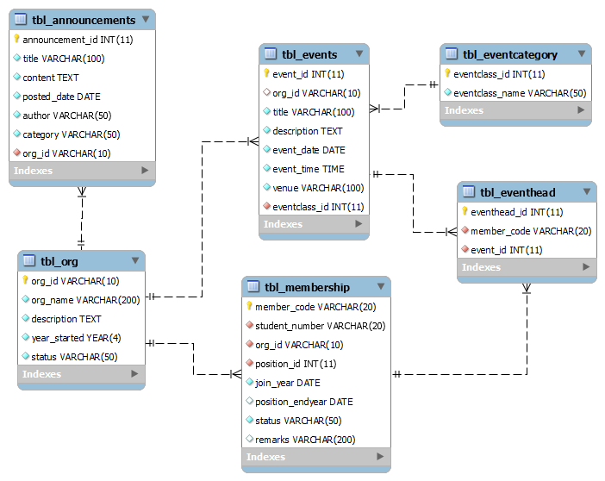

*Figure 12. Events and Announcement Module of the proposed system*

1. **tbl_annoucements:**

* Purpose: tbl_announcements is responsible for storing information about announcements posted in the system. It includes attributes such as announcement_id (unique identifier), title, content, posted_date, author, category, and org_id (foreign key). This table keeps track of all the announcements made within the system.
* Relationship: tbl_announcements is related to tbl_org through the org_id foreign key. This relationship allows the system to link each announcement to the specific organization it is associated with, providing context and categorization for announcements.

1. **tbl_events:**

* Purpose: tbl_events is responsible for storing information about various events organized or hosted by different organizations. It includes attributes such as event_id (unique identifier), org_id (foreign key), title, description, event_date, event_time, and venue. This table serves as a registry of all events taking place in the system.
* Relationship: tbl_events is related to tbl_org through the org_id foreign key. This relationship allows the system to link each event to the specific organization that organizes or hosts it, making event management more organized and accessible.

1. **tbl_event_category:**

* Purpose: tbl_eventcategory serves as a reference table in the Events & Announcements Module, storing information about event categories or classifications. It includes attributes such as eventclass_id and eventclass_name, offering options for categorizing events based on their type or purpose.
* Relationship: tbl_eventcategory is not directly related to any other table in the module, but it serves as a lookup table to provide event category options for the events in tbl_events.

1. **tbl_eventhead:**

* Purpose: tbl_eventhead is a critical table in the Events & Announcements Module, responsible for recording information about event heads or organizers. It includes attributes such as eventhead_id, member_code (foreign key), and event_id (foreign key), keeping track of members designated as event heads for specific events.
* Relationship: tbl_eventhead is related to tbl_membership through the member_code foreign key. This relationship allows the system to link each event head to their membership data, providing essential information about the event head's name and contact details.

tbl_eventhead is connected to tbl_events through the event_id foreign key. This association enables the system to link each event head to the event they are organizing or in charge of, ensuring smooth event coordination.

# CAEPUPT2023_Interview – Sample Database Flow

*Figure 13. CAEPUPT2023_Interview – Sample Database Flow*

The CAEPUPT2023 Interview Module is responsible for managing information related to interviews conducted for the CAEPUPT2023 or the admission of new students at Polytechnic University of the Philippines – Taguig. Let's delve into the purpose of each table in this module:

1. **tbl_caepupt2023interview:**

* Purpose: tbl_caepupt2023interview is a central table in the CAEPUPT2023 Interview Module, responsible for storing data about individual interviews conducted for the CAEPUPT2023 event. It includes attributes such as volunteer_id (unique identifier), event_id (foreign key), member_code (foreign key), Date_assigned, Task, and Remarks. This table serves as a repository for all interview-related information.
* Relationship: tbl_caepupt2023interview is related to tbl_events through the event_id foreign key. This relationship allows the system to link each interview to the specific CAEPUPT2023 event it is associated with, ensuring proper event tracking and organization.

tbl_caepupt2023interview is connected to tbl_membership through the member_code foreign key. This association enables the system to link each interview to the specific organization member who volunteered for the interview, providing relevant participant details.

1. **tbl_membership:**

* Purpose: tbl_membership plays a critical role in the CAEPUPT2023 Interview Module as it contains essential information about organization membership. It includes attributes such as member_code (unique identifier), student_number (foreign key), org_id (foreign key), position_id (foreign key), join_year, position_endyear, status, and remarks. This table serves as the central repository for all membership-related data.
* Relationship: tbl_membership is related to tbl_studentinfo through the student_number foreign key. This relationship allows the system to link each membership record to the specific student's information, providing essential details like name, contact information, and course.

tbl_membership is related to tbl_org through the org_id foreign key. This relationship enables the system to link each membership to the respective organization, helping in organizing members based on their affiliated organizations.

tbl_membership is connected to tbl_positions through the position_id foreign key. This association allows the system to link each membership to the specific position held by the member within the organization.

1. **tbl_events:**

* Purpose: tbl_events plays a crucial role in the CAEPUPT2023 Interview Module as it contains information about the CAEPUPT2023 event itself. It includes attributes such as event_id (unique identifier), org_id (foreign key), title, description, event_date, event_time, and venue. This table serves as a repository for all event-related data.
* Relationship: tbl_events is related to tbl_org through the org_id foreign key. This relationship allows the system to link the CAEPUPT2023 event to the specific organization hosting the event, ensuring proper organization and categorization of the event.

tbl_events is connected to tbl_eventcategory through the eventclass_id foreign key. This association allows the system to categorize the CAEPUPT2023 event under a specific event category specified in tbl_eventcategory.

1. **tbl_category:**

* Purpose: tbl_eventcategory serves as a reference table for event categories or classifications. It stores different event categories, allowing users to categorize events based on their type or purpose. This table provides a standardized list of event classifications for easy selection when categorizing events in the system.
* Relationship: tbl_eventcategory is connected to tbl_events through the eventclass_id foreign key. This association enables events, including the CAEPUPT2023 event, to be categorized under different event categories specified in tbl_eventcategory.

1. **tbl_org:**

* Purpose: tbl_org serves as the central table for storing organization data, including the organization's information related to the CAEPUPT2023 event. It contains attributes such as org_id (unique identifier), org_name, description, year_started, and status. This table provides an overview of all registered organizations, including those participating in the CAEPUPT2023 event.
* Relationship: tbl_org is related to tbl_events through the org_id foreign key. This relationship allows the system to link each organization to the specific events they host or participate in, including the CAEPUPT2023 event.

The tables presented in the Sample Database Flow were created as part of the development process for our proposed system. The team saw an opportunity to utilize this project to provide an example of the system's database structure. While some data might be entered directly into Excel for convenience, the team recognized the importance of having a well-organized and efficient database to handle the complexity of the system's functionalities. As a result, the tables were designed to represent the key modules and relationships within the system, allowing for seamless data management and smooth execution of the various processes involved.

As the CAEPUPT2023 Interview Module aims to manage interviews conducted for the admission of new students at Polytechnic University of the Philippines - Taguig, the tables within this module serve distinct purposes and play crucial roles in facilitating efficient data management and organization.

In conclusion, the CAEPUPT2023 Interview Module's well-designed tables and relationships contribute to a seamless and efficient admission process for new students at PUPT Taguig. By utilizing this comprehensive database system, the university can optimize its organization management, empowering students, faculty, and administrators to achieve collective goals and objectives, fostering a vibrant and dynamic campus community, and enriching the overall student experience.

# SQL Queries

# SQL Query to create the database

| CREATE DATABASE casestudy_OMS;  USE casestudy_OMS; |
| --- |

# SQL Query to create the tables

| CREATE TABLE tbl_userrole (  role_id INT PRIMARY KEY AUTO_INCREMENT,  role_name VARCHAR(50) NOT NULL UNIQUE,  description TEXT NOT NULL  );  CREATE TABLE tbl_login (  user_id INT PRIMARY KEY AUTO_INCREMENT,  username VARCHAR(50) NOT NULL UNIQUE,  password VARCHAR(255) NOT NULL,  role_id INT NOT NULL,  FOREIGN KEY (role_id) REFERENCES tbl_userrole (role_id)  );  CREATE TABLE tbl_session (  session_id INT PRIMARY KEY AUTO_INCREMENT,  user_id INT NOT NULL,  login_time DATETIME NOT NULL,  activity_time DATETIME NOT NULL,  FOREIGN KEY (user_id) REFERENCES tbl_login (user_id)  );  CREATE TABLE tbl_org (  org_id VARCHAR(10) PRIMARY KEY,  org_name VARCHAR(200) NOT NULL UNIQUE,  description TEXT NOT NULL,  year_started YEAR NOT NULL,  status VARCHAR(50) NOT NULL  );  CREATE TABLE tbl_orgadviser (  adviser_id INT PRIMARY KEY AUTO_INCREMENT,  org_id VARCHAR(10) NOT NULL,  adviser_name VARCHAR(200) NOT NULL,  adviser_email VARCHAR(100) NOT NULL,  FOREIGN KEY (org_id) REFERENCES tbl_org (org_id)  );  CREATE TABLE tbl_positions (  position_id INT PRIMARY KEY AUTO_INCREMENT,  title VARCHAR(50) NOT NULL UNIQUE,  description TEXT NOT NULL  );  CREATE TABLE tbl_studentinfo (  student_number VARCHAR(20) PRIMARY KEY,  firstname VARCHAR(50) NOT NULL,  middlename VARCHAR(50),  lastname VARCHAR(50) NOT NULL,  gender VARCHAR(1) NOT NULL,  address VARCHAR(100) NOT NULL,  email VARCHAR(50) NOT NULL,  mobile VARCHAR(15) NOT NULL,  birthdate DATE NOT NULL,  course_and_section VARCHAR(50) NOT NULL  );  CREATE TABLE tbl_membership (  member_code VARCHAR(20) PRIMARY KEY,  student_number VARCHAR(20) NOT NULL,  org_id VARCHAR(10) NOT NULL,  position_id INT NOT NULL,  join_year DATE NOT NULL,  position_endyear DATE,  status VARCHAR(50) NOT NULL,  remarks VARCHAR(200),  FOREIGN KEY (student_number) REFERENCES tbl_studentinfo (student_number),  FOREIGN KEY (org_id) REFERENCES tbl_org (org_id),  FOREIGN KEY (position_id) REFERENCES tbl_positions (position_id)  );  CREATE TABLE tbl_predecessor (  formerofficer_id INT PRIMARY KEY AUTO_INCREMENT,  member_code VARCHAR(20) NOT NULL,  position_id INT NOT NULL,  year_started DATE NOT NULL,  year_ended DATE NOT NULL,  FOREIGN KEY (member_code) REFERENCES tbl_membership (member_code),  FOREIGN KEY (position_id) REFERENCES tbl_positions (position_id)  );  CREATE TABLE tbl_voters (  voter_id INT PRIMARY KEY AUTO_INCREMENT,  member_code VARCHAR(20) NOT NULL,  FOREIGN KEY (member_code) REFERENCES tbl_membership (member_code)  );  CREATE TABLE tbl_candidates (  candidate_id INT PRIMARY KEY,  member_code VARCHAR(20) NOT NULL,  position_id INT NOT NULL,  remarks VARCHAR(200),  FOREIGN KEY (member_code) REFERENCES tbl_membership (member_code),  FOREIGN KEY (position_id) REFERENCES tbl_positions (position_id)  );  CREATE TABLE tbl_votes (  vote_id INT PRIMARY KEY AUTO_INCREMENT,  voter_id INT NOT NULL,  candidate_id INT NOT NULL,  CONSTRAINT UNIQUE_VOTE UNIQUE (voter_id, candidate_id),  FOREIGN KEY (voter_id) REFERENCES tbl_voters (voter_id),  FOREIGN KEY (candidate_id) REFERENCES tbl_candidates (candidate_id)  );  CREATE TABLE tbl_eventcategory (  eventclass_id INT PRIMARY KEY AUTO_INCREMENT,  eventclass_name VARCHAR(50) NOT NULL  );  CREATE TABLE tbl_events (  event_id INT PRIMARY KEY AUTO_INCREMENT,  org_id VARCHAR(10),  title VARCHAR(100) NOT NULL,  description TEXT NOT NULL,  event_date DATE NOT NULL,  event_time TIME NOT NULL,  venue VARCHAR(100) NOT NULL,  eventclass_id INT NOT NULL,  FOREIGN KEY (org_id) REFERENCES tbl_org (org_id),  FOREIGN KEY (eventclass_id) REFERENCES tbl_eventcategory (eventclass_id)  );  CREATE TABLE tbl_eventhead (  eventhead_id INT PRIMARY KEY AUTO_INCREMENT,  member_code VARCHAR(20) NOT NULL,  event_id INT NOT NULL,  FOREIGN KEY (member_code) REFERENCES tbl_membership (member_code),  FOREIGN KEY (event_id) REFERENCES tbl_events (event_id)  );  CREATE TABLE tbl_announcements (  announcement_id INT PRIMARY KEY AUTO_INCREMENT,  title VARCHAR(100) NOT NULL,  content TEXT NOT NULL,  posted_date DATE NOT NULL,  author VARCHAR(50) NOT NULL,  category VARCHAR(50) NOT NULL,  org_id VARCHAR(10),  FOREIGN KEY (org_id) REFERENCES tbl_org (org_id)  );  CREATE TABLE tbl_caepupt2023interview (  volunteer_id INT PRIMARY KEY AUTO_INCREMENT,  event_id INT NOT NULL,  member_code VARCHAR(20) NOT NULL,  Date_assigned DATE NOT NULL,  Task VARCHAR(50) NOT NULL,  Remarks VARCHAR(200),  FOREIGN KEY (event_id) REFERENCES tbl_events (event_id),  FOREIGN KEY (member_code) REFERENCES tbl_membership (member_code)  ); |
| --- |

# SQL Query to populate the tables

| CREATE TABLE tbl_userrole (  role_id INT PRIMARY KEY AUTO_INCREMENT,  role_name VARCHAR(50) NOT NULL UNIQUE,  description TEXT NOT NULL  );  CREATE TABLE tbl_login (  user_id INT PRIMARY KEY AUTO_INCREMENT,  username VARCHAR(50) NOT NULL UNIQUE,  password VARCHAR(255) NOT NULL,  role_id INT NOT NULL,  FOREIGN KEY (role_id) REFERENCES tbl_userrole (role_id)  );  CREATE TABLE tbl_session (  session_id INT PRIMARY KEY AUTO_INCREMENT,  user_id INT NOT NULL,  login_time DATETIME NOT NULL,  activity_time DATETIME NOT NULL,  FOREIGN KEY (user_id) REFERENCES tbl_login (user_id)  );  CREATE TABLE tbl_org (  org_id VARCHAR(10) PRIMARY KEY,  org_name VARCHAR(200) NOT NULL UNIQUE,  description TEXT NOT NULL,  year_started YEAR NOT NULL,  status VARCHAR(50) NOT NULL  );  CREATE TABLE tbl_orgadviser (  adviser_id INT PRIMARY KEY AUTO_INCREMENT,  org_id VARCHAR(10) NOT NULL,  adviser_name VARCHAR(200) NOT NULL,  adviser_email VARCHAR(100) NOT NULL,  FOREIGN KEY (org_id) REFERENCES tbl_org (org_id)  );  CREATE TABLE tbl_positions (  position_id INT PRIMARY KEY AUTO_INCREMENT,  title VARCHAR(50) NOT NULL UNIQUE,  description TEXT NOT NULL  );  CREATE TABLE tbl_studentinfo (  student_number VARCHAR(20) PRIMARY KEY,  firstname VARCHAR(50) NOT NULL,  middlename VARCHAR(50),  lastname VARCHAR(50) NOT NULL,  gender VARCHAR(1) NOT NULL,  address VARCHAR(100) NOT NULL,  email VARCHAR(50) NOT NULL,  mobile VARCHAR(15) NOT NULL,  birthdate DATE NOT NULL,  course_and_section VARCHAR(50) NOT NULL  );  CREATE TABLE tbl_membership (  member_code VARCHAR(20) PRIMARY KEY,  student_number VARCHAR(20) NOT NULL,  org_id VARCHAR(10) NOT NULL,  position_id INT NOT NULL,  join_year DATE NOT NULL,  position_endyear DATE,  status VARCHAR(50) NOT NULL,  remarks VARCHAR(200),  FOREIGN KEY (student_number) REFERENCES tbl_studentinfo (student_number),  FOREIGN KEY (org_id) REFERENCES tbl_org (org_id),  FOREIGN KEY (position_id) REFERENCES tbl_positions (position_id)  );  CREATE TABLE tbl_predecessor (  formerofficer_id INT PRIMARY KEY AUTO_INCREMENT,  member_code VARCHAR(20) NOT NULL,  position_id INT NOT NULL,  year_started DATE NOT NULL,  year_ended DATE NOT NULL,  FOREIGN KEY (member_code) REFERENCES tbl_membership (member_code),  FOREIGN KEY (position_id) REFERENCES tbl_positions (position_id)  );  CREATE TABLE tbl_voters (  voter_id INT PRIMARY KEY AUTO_INCREMENT,  member_code VARCHAR(20) NOT NULL,  FOREIGN KEY (member_code) REFERENCES tbl_membership (member_code)  );  CREATE TABLE tbl_candidates (  candidate_id INT PRIMARY KEY,  member_code VARCHAR(20) NOT NULL,  position_id INT NOT NULL,  remarks VARCHAR(200),  FOREIGN KEY (member_code) REFERENCES tbl_membership (member_code),  FOREIGN KEY (position_id) REFERENCES tbl_positions (position_id)  );  CREATE TABLE tbl_votes (  vote_id INT PRIMARY KEY AUTO_INCREMENT,  voter_id INT NOT NULL,  candidate_id INT NOT NULL,  CONSTRAINT UNIQUE_VOTE UNIQUE (voter_id, candidate_id),  FOREIGN KEY (voter_id) REFERENCES tbl_voters (voter_id),  FOREIGN KEY (candidate_id) REFERENCES tbl_candidates (candidate_id)  );  CREATE TABLE tbl_eventcategory (  eventclass_id INT PRIMARY KEY AUTO_INCREMENT,  eventclass_name VARCHAR(50) NOT NULL  );  CREATE TABLE tbl_events (  event_id INT PRIMARY KEY AUTO_INCREMENT,  org_id VARCHAR(10),  title VARCHAR(100) NOT NULL,  description TEXT NOT NULL,  event_date DATE NOT NULL,  event_time TIME NOT NULL,  venue VARCHAR(100) NOT NULL,  eventclass_id INT NOT NULL,  FOREIGN KEY (org_id) REFERENCES tbl_org (org_id),  FOREIGN KEY (eventclass_id) REFERENCES tbl_eventcategory (eventclass_id)  );  CREATE TABLE tbl_eventhead (  eventhead_id INT PRIMARY KEY AUTO_INCREMENT,  member_code VARCHAR(20) NOT NULL,  event_id INT NOT NULL,  FOREIGN KEY (member_code) REFERENCES tbl_membership (member_code),  FOREIGN KEY (event_id) REFERENCES tbl_events (event_id)  );  CREATE TABLE tbl_announcements (  announcement_id INT PRIMARY KEY AUTO_INCREMENT,  title VARCHAR(100) NOT NULL,  content TEXT NOT NULL,  posted_date DATE NOT NULL,  author VARCHAR(50) NOT NULL,  category VARCHAR(50) NOT NULL,  org_id VARCHAR(10),  FOREIGN KEY (org_id) REFERENCES tbl_org (org_id)  );  CREATE TABLE tbl_caepupt2023interview (  volunteer_id INT PRIMARY KEY AUTO_INCREMENT,  event_id INT NOT NULL,  member_code VARCHAR(20) NOT NULL,  Date_assigned DATE NOT NULL,  Task VARCHAR(50) NOT NULL,  Remarks VARCHAR(200),  FOREIGN KEY (event_id) REFERENCES tbl_events (event_id),  FOREIGN KEY (member_code) REFERENCES tbl_membership (member_code)  );  INSERT INTO tbl_userrole (role_name, description)  VALUES  ('Admin', 'Administrator role with full access.'),  ('Moderator', 'Moderator role with limited access.'),  ('Member', 'Standard member role.');  INSERT INTO tbl_login (username, password, role_id)  VALUES  ('puptoms', SHA2('puptoms', 256), 1),  ('csc.pup.edu.ph', SHA2('cscaccess', 256), 2),  ('cs.internal', SHA2('internal123', 256), 3);  INSERT INTO tbl_session (user_id, login_time, activity_time)  VALUES  (1, '2023-07-15 10:00:00', '2023-07-15 10:30:00'),  (2, '2023-07-15 11:00:00', '2023-07-15 11:45:00'),  (3, '2023-07-15 12:00:00', '2023-07-15 12:15:00');  INSERT INTO tbl_org (org_id, org_name, description, year_started, status)  VALUES  ('YOURCSC', 'YOUR Central Student Council', 'Academic Organization - The Official Facebook page of PUP Taguig Central Student Council', '2023', 'Active'),  ('AECES', 'The AECEs', 'Academic Organization - The Official Facebook page of the Association of Electronics Engineering Students - the accredited', '2023', 'Active'),  ('CS', 'PUP Taguig Computer Society', 'Academic Organization - PUP Taguig Computer Society is the official union of BSIT and DICT students of the Polytechnic University', '2023', 'Active'),  ('JMA', 'Junior Marketing Association PUP Taguig', 'Academic Organization - The official Facebook page of PUPT - Junior Marketing Association', '2023', 'Active'),  ('JPIA', 'Junior Philippine Institute of Accountants - PUP Taguig', 'Academic Organization - Junior Philippine Institute of Accountants of Polytechnic University of the Philippines - Taguig', '2023', 'Active'),  ('JPMAP', 'Junior People Management Association of the Philippines - PUPT Chapter', 'Academic Organization - The official academic organization for human resources student of PUP Taguig', '2023', 'Active'),  ('MS', 'Mentors Society', 'Academic Organization - The Mentors Society is the education students of the College of Education of PUP-Taguig', '2023', 'Active'),  ('PASOA', 'Philippine Association of Students in Office Administration-PUP Taguig', 'Academic Organization - The Official Facebook page of Philippine Association of Students in Office Administration-PUP Taguig', '2023', 'Active'),  ('PSME', 'Philippine Society of Mechanical Engineers - PUP Taguig Student Unit', 'Academic Organization - The Official Facebook page of Philippine Society of Mechanical Engineers - PUP Taguig Student Unit', '2023', 'Active'),  ('ERG', 'Emergency Response Group', 'Non-Academic Organization - The Emergency Response Group (ERG) is an official non-academic organization of PUP-Taguig', '2023', 'Active'),  ('iRock', 'iRock Campus - PUP Taguig', 'Non-Academic Organization - iRock Campus - PUP Taguig', '2023', 'Active'),  ('PUPUKAW', 'Politeknikong Unibersidad ng Pilipinas Ugat ng Kamalayang Aktibo sa Wika', 'Non-Academic Organization - Ugat ng Kamalayang Aktibo sa Wika', '2023', 'Active'),  ('REC', 'Radio Engineering Circle', 'Non-Academic Organization - The Official Facebook Page of Radio Engineering Circle, Inc.', '2023', 'Active');    INSERT INTO tbl_orgadviser (org_id, adviser_name, adviser_email)  VALUES  ('YOURCSC', 'Bernadette Canlas', 'bernadette.canlas@gmail.com'),  ('AECES', 'Jerome Santos', 'jerome.santos@gmail.com'),  ('JMA', 'John Carlo Reyes', 'john.carlo.reyes@gmail.com'),  ('JPIA', 'Kristine Garcia', 'kristine.garcia@gmail.com'),  ('JPMAP', 'Michelle Lim', 'michelle.lim@gmail.com'),  ('MS', 'Rodel Soriano', 'rodel.soriano@gmail.com'),  ('PASOA', 'Paula Martinez', 'paula.martinez@gmail.com'),  ('PSME', 'Ronald Dela Cruz', 'ronald.delacruz@gmail.com'),  ('ERG', 'Marvin Reyes', 'marvin.reyes@gmail.com'),  ('iRock', 'Angela Torres', 'angela.torres@gmail.com'),  ('PUPUKAW', 'Josephine Santiago', 'josephine.santiago@gmail.com'),  ('REC', 'Mark Torres', 'mark.torres@gmail.com');  INSERT INTO tbl_positions (title, description)  VALUES  ('President', 'Description for President position'),  ('VP Internal', 'Description for VP Internal'),  ('VP External', 'Description for VP External'),  ('Treasurer', 'Description for Treasurer'),  ('Secretary-General', 'Description for Secretary-General'),  ('Asst. Treasurer', 'Description for Asst. Treasurer'),  ('Auditor', 'Description for Auditor'),  ('P.R.O', 'Description for P.R.O'),  ('Business Manager', 'Description for Business Manager'),  ('AECES Representative', 'Description for AECES Representative'),  ('CS Representative', 'Description for CS Representative'),  ('JMA Representative', 'Description for JMA Representative'),  ('JPIA Representative', 'Description for JPIA Representative'),  ('JPMAP Representative', 'Description for JPMAP Representative'),  ('MS Representative', 'Description for MS Representative'),  ('PSME Representative', 'Description for PSME Representative'),  ('PASOA Representative', 'Description for PASOA Representative'),  ('OverKnights', 'Description for OverKnights'),  ('VP for Records', 'Description for VP for Records'),  ('AVP for Records', 'Description for AVP for Records'),  ('VP for Research and Documentation', 'Description for VP for Research and Documentation'),  ('AVP for Research and Documentaion', 'Description for AVP for Research and Documentation'),  ('VP for Finance', 'Description for VP for Finance'),  ('AVP for Finance', 'Description for AVP for Finance'),  ('VP for Audit', 'Description for VP for Audit'),  ('AVP for Audit', 'Description for AVP for Audit'),  ('VP for Communication', 'Description for VP for Communication'),  ('AVP for Communication', 'Description for AVP for Communication'),  ('Communication Committee', 'Description for Communication Committee'),  ('Director for Academics', 'Description for Director for Academics'),  ('Co-director for Academics', 'Description for Co-director for Academics'),  ('Academics Committee', 'Description for Academics Committee'),  ('Director for Creatives', 'Description for Director for Creatives'),  ('Co-director for Creatives', 'Description for Co-director for Creatives'),  ('Creatives Committee', 'Description for Creatives Committee'),  ('Director for Sports', 'Description for Director for Sports'),  ('Co-director for Sports', 'Description for Co-director for Sports'),  ('Delegates Representative ', 'Description for Delegates Representative'),  ('Member', 'Description for Member');  INSERT INTO tbl_studentinfo (student_number, firstname, middlename, lastname, gender, address, email, mobile, birthdate, course_and_section)  VALUES  ('2021-00153-TG-0', 'Andrei James', 'Suanes', 'Alejandro', 'M', '128 D MLQ St. Purok 2 New Lower Bicutan Taguig City', 'squishycaptain09@gmail.com', '09091350852', '2003-10-09', 'BSIT 2-1'),  ('2021-00158-TG-0', 'Kaila Marie', 'Aquino', 'Alima', 'F', 'Block 67 Lot 9 Phase 4 Malvar St. Upper Bicutan, Taguig City', '12malvar.alimakailamarie@gmail.com', '09517757535', '2002-06-01', 'BSIT 2-1'),  ('2021-00154-TG-0', 'Cristina Arwen', 'Taimbe', 'Andongan', 'F', 'Blk 177 Lot 1 IRM Rd. Maharlika Taguig City.', 'cristinaarwenandongan30@gmail.com', '09533815507', '2002-10-30', 'BSIT 2-1'),  ('2021-00155-TG-0', 'Chrystine Noelle', 'Monterola', 'Asebuque', 'F', 'Block 4 Lot 3A Mercury St., Nuwhrain Village, Putatan, Muntinlupa City', 'asebuquechrystine@gmail.com', '09665700310', '2003-02-19', 'BSIT 2-1'),  ('2021-00159-TG-0', 'Kylie Ross',NULL, 'Ayacocho', 'F', '61 Sampaloc Extension Zone 1, North Signal Village, Taguig City', 'kylieross.ayacocho@gmail.com', '09150890230', '2003-01-03', 'BSIT 2-1'),  ('2021-00156-TG-0', 'Bradley', 'Cabillan', 'Cainday', 'M', '20-A Col. Bravo St. Zone 5, Central Signal Village, Taguig City', 'bradleycainday@gmail.com', '09760292478', '2002-09-14', 'BSIT 2-1'),  ('2021-00157-TG-0', 'Pearl', 'Carpio', 'Calderon', 'F', 'Block 2 Lot 9, Radar Technical Village, Brgy. 201, Pasay City', 'calderon.pearl12@gmail.com', '09760430517', '2002-12-12', 'BSIT 2-1'),  ('2021-00160-TG-0', 'Jun Rey', 'Bernaldez', 'Carnacite', 'M', '48 Sampaguita st. Brngy Sta Ana Taytay Rizal', 'carnacitejunrey@gmail.com', '09090779295', '2002-06-27', 'BSIT 2-1'),  ('2021-00161-TG-0', 'Angel Rose', 'Hernandez', 'Casabuena', 'F', 'Purok 1, Bugaan West, Laurel, Batangas', 'casabuenaangelrose1123@gmail.com', '09281500075', '2002-11-23', 'BSIT 2-1'),  ('2021-00162-TG-0', 'Karen Alonica', 'Celicious', 'Casim', 'F', 'Block 140 Lot 39 Phase 7 Sitio Imelda Upper Bicutan Taguig City', 'karennicacasim.1124@gmail.com', '09121539158', '2002-11-24', 'BSIT 2-1'),  ('2021-00200-TG-0', 'Kazel', 'Salen', 'Villamarzo', 'F', 'Lot 1B Blk 2 Road 2 Pavahai Comembo Makati City', 'kazelvillamarzo@gmail.com', '09650852996', '2002-02-25', 'BSIT 2-1'),  ('2021-00201-TG-0', 'Kimberly April', 'Jallores', 'Villanueva', 'F', '#10 Barangay Street Purok 6 Lower Bicutan Taguig City', 'villanuevakimberly33@gmail.com', '09386198118', '2003-04-15', 'BSIT 2-1'),  ('2021-00163-TG-0', 'Krystel Caye', 'Ricafort', 'Castillo', 'F', 'Block 4 Lot 21 Jamcels Villa Arciaga San Guillermo St., Bayanan, Muntinlupa City', 'krystelcayecastillo00@gmail.com', '09491540370', '2003-07-11', 'BSIT 2-1'),  ('2021-00164-TG-0', 'Aiza Mae', 'Corpuz', 'Castro', 'F', '#10 Road 21 North Daang Hari, Taguig City', 'castroaiza28@gmail.com', '09953542179', '2002-10-09', 'BSIT 2-1'),  ('2021-00165-TG-0', 'Simounne', 'Gomez', 'Cruz', 'F', '273 Estehonor Comp. Wawa St. Alabang, Muntinlupa City', 'smnncruz@gmail.com', '09493945111', '2003-05-03', 'BSIT 2-1'),  ('2021-00178-TG-0', 'Mary Joy', 'Megido', 'Danay', 'F', 'Blk 18 Lot 6 Southville 8, Brgy. San Isidro, Rodriguez, Rizal', 'maryjoydanay2.0@gmail.com', '09102908864', '1999-05-30', 'BSIT 2-1'),  ('2021-00166-TG-0', 'Reymond Christian', 'Ausa', 'Despe', 'M', 'Blk 3 Lot 9 P-1 Central Bicutan, Taguig City', 'christian.despe25@gmail.com', '09773943590', '2003-01-25', 'BSIT 2-1'),  ('2021-00167-TG-0', 'Andronicus', 'Reyes', 'Dimasacat', 'M', '26A INT MLQ. St. Prk 1, New Lower Bicutan Taguig City', 'andri.dimasacat@gmail.com', '09995328677', '2002-08-11', 'BSIT 2-1'),  ('2021-00168-TG-0', 'Judy Ann', 'Mendez', 'Dupo', 'F', '17A Mais Street, Western Bicutan, Taguig City', 'judyannemendez1212@gmail.com', '09350525714', '2002-12-12', 'BSIT 2-1'),  ('2021-00169-TG-0', 'Nicole', 'Carpio', 'Ebrada', 'F', 'Unit 103, Building 19, Ciudad de Strike, Molino I, City of Bacoor, Cavite', 'ncebrada02@gmail.com', '09165544473', '2002-04-12', 'BSIT 2-1'),  ('2021-00170-TG-0', 'Arvin', 'Llames', 'Embo', 'M', 'Blk 140 Lot 35 Prk 6 Upper Bicutan Taguig City', 'cssy70835@gmail.com', '09563347962', '2002-09-17', 'BSIT 2-1'),  ('2021-00171-TG-0', 'Diana Rose', 'Villarena', 'Fidel', 'F', '461 M.L Que. St. Purok 6 Brgy. Lower Bicutan Taguig, City', 'fideldianarose@gmail.com', '09276274257', '2002-11-12', 'BSIT 2-1'),  ('2021-00172-TG-0', 'Jhean Khendrick', 'Casane', 'Galope', 'M', '67 Ilaya Street, Alabang, Muntinlupa City', 'drakekhendrick@gmail.com', '09151676868', '2002-12-05', 'BSIT 2-1'),  ('2021-00173-TG-0', 'Christian Harrel', 'Yturzaita', 'Go', 'M', '05 Martinez St., Zone 4, South Signal Village, Taguig City', 'chrome.go.christianharrel@gmail.com', '09457088118', '2002-11-12', 'BSIT 2-1'),  ('2021-00174-TG-0', 'Carlo', 'Motay', 'Gunabe', 'M', '139 Pulo I Dalahican, Cavite City, Cavite', 'zeddpogi25@gmail.com', '09513349152', '2002-08-25', 'BSIT 2-1'),  ('2021-00175-TG-0', 'Adnan', 'Tumindeg', 'Hassan', 'M', 'Blk 31 Lot 15 Barracks Street, Maharlika Village, Taguig City', 'adnanhassanda@gmail.com', '09460994104', '2002-08-03', 'BSIT 2-1'),  ('2021-00176-TG-0', 'Joanna Marie', 'Dalugdugan', 'Intia', 'F', '13 Pardiñas St. Zone 6 South Signal Village Taguig City', 'joannaintia27@gmail.com', '09154617650', '2002-09-27', 'BSIT 2-1'),  ('2021-00177-TG-0', 'Reanne Rylle', 'Celestino', 'Jalipa', 'M', 'Blk. 159 Lt. 16 Central Bicutan Taguig', 'rylle1588@gmail.com', '09479513303', '2003-01-15', 'BSIT 2-1'),  ('2021-00179-TG-0', 'Alkhaizar', 'Sahali', 'Jambiran', 'M', 'Blk 180 Lot 50 Barracks St., Maharlika Village, Taguig City', 'jambiranalkhaizar@gmail.com', '09611270878', '2002-05-21', 'BSIT 2-1'),  ('2021-00181-TG-0', 'Emanuel John', 'Criste', 'Lopez', 'M', '240 MLQ Street Purok 5, Lower Bicutan, Taguig City', 'emanueljohnlopez221322@gmail.com', '09456530571', '2002-06-13', 'BSIT 2-1'),  ('2021-00180-TG-0', 'Jhon Lay', 'Garcia', 'Lopez', 'M', '08 St. Joseph Merville Pasay City', 'jhonlaylopez2@gmail.com', '09099056766', '2003-08-02', 'BSIT 2-1'),  ('2021-00182-TG-0', 'Melanie Carmela', 'Mauricio', 'Macazo', 'F', '384, MLQ Street Purok 5, Lower Bicutan, Taguig City', 'melaniemacazo@gmail.com', '09454087280', '2003-09-17', 'BSIT 2-1'),  ('2021-00183-TG-0', 'Kyla Rica', 'Catu', 'Malaluan', 'F', '7C Ilaya Alabang Muntinlupa City', 'malaluankylarica@gmail.com', '09267001140', '2002-11-02', 'BSIT 2-1'),  ('2021-00184-TG-0', 'Mark Angelo', 'Mabagos', 'Manzanas', 'M', 'B7 L10 EP Housing Village Barangay Pinagsama Taguig City.', 'appleapolmanzanas@gmail.com', '09167818564', '2002-03-06', 'BSIT 2-1'),  ('2019-00233-TG-0', 'Miles Emmanuel', 'Quinco', 'Martinez', 'M', 'B120 L8 Sitio Imelda Upper Bicutan, Taguig', 'emmanuelmartinez013@outlook.com', '09274596753', '2001-09-18', 'BSIT 2-1'),  ('2021-00185-TG-0', 'Almera', 'Gayak', 'Mentok', 'F', 'Block 131 Lot 2 Phase 8 Sitio Imelda Upper Bicutan, Taguig City', 'almerageementok@gmail.com', '09982819100', '2003-03-02', 'BSIT 2-1'),  ('2021-00186-TG-0', 'Ed Judah', 'Espiñe', 'Mingo', 'M', '#23 Katipunan St. Bambang Taguig City', 'edjudah.ej@gmail.com', '09517775932', '2003-04-19', 'BSIT 2-1'),  ('2021-00187-TG-0', 'Jeff Carl', 'Macaraig', 'Monroy', 'M', '3776 Padilla St. Purok 6-B, Lower Bicutan, Taguig City', 'jeffcmonroy@gmail.com', '09557040152', '2003-05-02', 'BSIT 2-1'),  ('2021-00188-TG-0', 'James', 'Villaruel', 'Nabayra', 'M', '#107 Darimbang Street, Maharlika Village, Taguig City', 'james.nabayra029@gmail.com', '09389706412', '2002-06-29', 'BSIT 2-1'),  ('2021-00189-TG-0', 'Adrian', 'Bico', 'Naoe', 'M', 'Phase 4 Block 2 Lot 14, Southville 3 NHA Poblacion, Muntinlupa City', 'adriannaoe7@gmail.com', '09051497940', '2003-03-24', 'BSIT 2-1'),  ('2021-00190-TG-0', 'Mark Ryan', 'Juare', 'Odrunia', 'M', '16 Manggahan St. Zone-4, South signal Village, Taguig City', 'odruniamarkryan@gmail.com', '09506367920', '2003-04-25', 'BSIT 2-1'),  ('2021-00191-TG-0', 'Arzel Fernando', 'Vistuir', 'Pascual', 'M', 'Blk. 2 Lot 13 PNAI HOA, Calzada Tipas, Taguig City', 'arzelpascualpascual@gmail.com', '09461647733', '2002-12-15', 'BSIT 2-1'),  ('2021-00192-TG-0', 'John Patrick', 'Maur', 'Perez', 'M', 'Blk 150 Lot 41 Contreras St, Central Bicutan, Taguig City', 'johnpatrickperezxx@gmail.com', '09081787473', '2003-03-20', 'BSIT 2-1'),  ('2021-00193-TG-0', 'Via Clariz', 'Abrilla', 'Rasquero', 'F', 'Blk 17 Lot 11 Tulip St. Camella Homes 1 Putatan, Muntinlupa City', 'viarasquero20@gmail.com', '09637940942', '2003-09-20', 'BSIT 2-1'),  ('2021-00194-TG-0', 'Samantha Nicole', 'Aldea', 'Sanchez', 'F', '521 Purok 2, ML Quezon Street, Sucat, Muntinlupa City', 'ssamanthanicole26@gmail.com', '09951257468', '2003-02-12', 'BSIT 2-1'),  ('2021-00195-TG-0', 'Catherine', 'Canja', 'Soriano', 'F', '# 46 Luzon St. Zone 5, Central Signal Village, Taguig City', 'catherine.c.sorianooo@gmail.com', '09662855570', '2002-08-02', 'BSIT 2-1'),  ('2021-00196-TG-0', 'Yves John', 'Bancolita', 'Tapispisan', 'M', '109 Balleser St. Zone 4, South Signal Village, Taguig City', 'bancolitayves@gmail.com', '09979003474', '2003-01-06', 'BSIT 2-1'),  ('2021-00197-TG-0', 'April Joy', 'Abela', 'Ternal', 'F', '42 Viscarra St. New Lower Bicutan Taguig City', 'ternalapriljoy@gmail.com', '09516617267', '2003-04-17', 'BSIT 2-1'),  ('2021-00198-TG-0', 'Jonnel', 'Tamayo', 'Tocmo', 'M', '21 Ckhai Balagbag, Brgy. 201, Pasay City', 'jonneltocmo137@gmail.com', '09292857089', '2003-08-09', 'BSIT 2-1'),  ('2021-00199-TG-0', 'Sir Lance', 'Marchan', 'Valerio', 'M', '114 MLQ. St., Prk. 2, New Lower Bicutan, Taguig City', 'vsirlance@gmail.com', '09072299451', '2003-03-20', 'BSIT 2-1'),  ('2021-00202-TG-0', 'Diana', 'Tanjutco', 'Villa-Villa', 'F', '25 MRT Avenue New Lower Bicutan Taguig City', 'diana.villavilla02@gmail.com', '09760242693', '2002-12-04', 'BSIT 2-1'),  ('2021-00150-TG-0', 'Keisha Mae', NULL, 'Operio', 'F', 'This is a sample address only, Taguig City', 'thisisasampleemailonly@gmail.com', '09994999647', '2002-01-11', 'DICT 2-1'),  ('2021-0012-0982', 'Jade Aubrey', NULL, 'Trinillia', 'F', 'This is a sample address only, Taguig City', 'thisisasampleemailonly@gmail.com', '09994999647', '2002-01-11', 'DICT 2-1'),  ('2021-00147-TG-0', 'Elinel', NULL, 'Aguada', 'M', 'This is a sample address only, Taguig City', 'thisisasampleemailonly@gmail.com', '09994999647', '2002-01-11', 'DICT 2-1'),  ('2021-00148-TG-0', 'Melrose', NULL, 'Alvarico', 'F', 'This is a sample address only, Taguig City', 'thisisasampleemailonly@gmail.com', '09994999647', '2002-01-11', 'DICT 2-1'),  ('2021-00149-TG-0', 'Pacita Francee', NULL, 'Angeles', 'F', 'This is a sample address only, Taguig City', 'thisisasampleemailonly@gmail.com', '09994999647', '2002-01-11', 'DICT 2-1'),  ('2021-0013-3500', 'Christel Ann', NULL, 'Baldomera', 'F', 'This is a sample address only, Taguig City', 'thisisasampleemailonly@gmail.com', '09994999647', '2002-01-11', 'DICT 2-1'),  ('2021-0016-5568', 'Sophia Joy', NULL, 'Bedrio', 'F', 'This is a sample address only, Taguig City', 'thisisasampleemailonly@gmail.com', '09994999647', '2002-01-11', 'DICT 2-1'),  ('2021-0014-4110', 'Marielle Francine', NULL, 'Borjal', 'F', 'This is a sample address only, Taguig City', 'thisisasampleemailonly@gmail.com', '09994999647', '2002-01-11', 'DICT 2-1'),  ('2021-0016-3851', 'Joanna Marie', NULL, 'Buli', 'F', 'This is a sample address only, Taguig City', 'thisisasampleemailonly@gmail.com', '09994999647', '2002-01-11', 'DICT 2-1'),  ('2021-0018-7754', 'John Vincent', NULL, 'Cañalita', 'M', 'This is a sample address only, Taguig City', 'thisisasampleemailonly@gmail.com', '09994999647', '2002-01-11', 'DICT 2-1'),  ('2021-00427-TG-0', 'Jhonel', NULL, 'Castillano', 'M', 'This is a sample address only, Taguig City', 'thisisasampleemailonly@gmail.com', '09994999647', '2002-01-11', 'DICT 2-1'),  ('2021-0016-9509', 'Sarah Victoria', NULL, 'Claud', 'F', 'This is a sample address only, Taguig City', 'thisisasampleemailonly@gmail.com', '09994999647', '2002-01-11', 'DICT 2-1'),  ('2021-00430-TG-0', 'Yujin Yuiko', NULL, 'Domo', 'M', 'This is a sample address only, Taguig City', 'thisisasampleemailonly@gmail.com', '09994999647', '2002-01-11', 'DICT 2-1'),  ('2021-0012-0703', 'Simon Genesis', NULL, 'Falcon', 'M', 'This is a sample address only, Taguig City', 'thisisasampleemailonly@gmail.com', '09994999647', '2002-01-11', 'DICT 2-1'),  ('2021-0012-0784', 'Jerick Miguel', NULL, 'Jose', 'M', 'This is a sample address only, Taguig City', 'thisisasampleemailonly@gmail.com', '09994999647', '2002-01-11', 'DICT 2-1'),  ('2021-0017-3625', 'Kathlyn Mae', NULL, 'Nofuente', 'F', 'This is a sample address only, Taguig City', 'thisisasampleemailonly@gmail.com', '09994999647', '2002-01-11', 'DICT 2-1'),  ('2021-0014-6143', 'Allysa Naoemie', 'Libre', 'Oliveros', 'F', 'This is a sample address only, Taguig City', 'thisisasampleemailonly@gmail.com', '09994999647', '2002-01-11', 'DICT 2-1'),  ('2021-0013-2864', 'James Patrick', NULL, 'Ovilla', 'M', 'This is a sample address only, Taguig City', 'thisisasampleemailonly@gmail.com', '09994999647', '2002-01-11', 'DICT 2-1'),  ('2021-0016-9726', 'Yuan Elijah Darthagnan', NULL, 'Pine', 'M', 'This is a sample address only, Taguig City', 'thisisasampleemailonly@gmail.com', '09994999647', '2002-01-11', 'DICT 2-1'),  ('2021-0000-8080', 'Jose Louise', NULL, 'Severo', 'M', 'This is a sample address only, Taguig City', 'thisisasampleemailonly@gmail.com', '09994999647', '2002-01-11', 'DICT 2-1'),  ('2021-0009-3477', 'Lance Ezekiel', NULL, 'Sicat', 'M', 'This is a sample address only, Taguig City', 'thisisasampleemailonly@gmail.com', '09994999647', '2002-01-11', 'DICT 2-1'),  ('2021-0012-2139', 'Crisdelle Anne', NULL, 'Vetus', 'F', 'This is a sample address only, Taguig City', 'thisisasampleemailonly@gmail.com', '09994999647', '2002-01-11', 'DICT 2-1'),  ('2021-0012-1762', 'Marc Danniel', NULL, 'Villaflores', 'M', 'This is a sample address only, Taguig City', 'thisisasampleemailonly@gmail.com', '09994999647', '2002-01-11', 'DICT 2-1'),  ('2021-0015-1830', 'John Jirald', NULL, 'Bragais', 'M', 'This is a sample address only, Taguig City', 'thisisasampleemailonly@gmail.com', '09994999647', '2002-01-11', 'DICT 2-1'),  ('2021-00151-TG-0', 'Jhester Ken', NULL, 'Goyena', 'M', 'This is a sample address only, Taguig City', 'thisisasampleemailonly@gmail.com', '09994999647', '2002-01-11', 'DICT 2-1'),  ('2021-0015-0948', 'Angelo King', NULL, 'Ladisla', 'M', 'This is a sample address only, Taguig City', 'thisisasampleemailonly@gmail.com', '09994999647', '2002-01-11', 'DICT 2-1'),  ('2021-00152-TG-0', 'Gwyneth Khaytte', NULL, 'Mallari', 'F', 'This is a sample address only, Taguig City', 'thisisasampleemailonly@gmail.com', '09994999647', '2002-01-11', 'DICT 2-1'),  ('2021-0016-9656', 'Mark Kian', NULL, 'Ariola', 'M', 'This is a sample address only, Taguig City', 'thisisasampleemailonly@gmail.com', '09994999647', '2002-01-11', 'DICT 2-1'),  ('2021-0016-6918', 'Cyrus Neil', NULL, 'Maquiñana', 'M', 'This is a sample address only, Taguig City', 'thisisasampleemailonly@gmail.com', '09994999647', '2002-01-11', 'DICT 2-1'),  ('2023-0000-0001', 'Daisylene Suzy', 'Sabando', 'Ross', 'F', 'This is a sample address only, Taguig City', 'thisisasampleemailonly@gmail.com', '09994999647', '2002-01-11', 'DICT 3-1'),  ('2023-0000-0002', 'John Reign', 'Moral', 'Encina', 'M', 'This is a sample address only, Taguig City', 'thisisasampleemailonly@gmail.com', '09994999647', '2002-01-11', 'BSIT 3-1'),  ('2023-0000-0003', 'Maria Arabella', 'Continedas', 'Pablo', 'F', 'This is a sample address only, Taguig City', 'thisisasampleemailonly@gmail.com', '09994999647', '2002-01-11', 'BSIT 3-1'),  ('2023-0000-0004', 'Michelle Via', 'Arcangel', 'Rediga', 'F', 'This is a sample address only, Taguig City', 'thisisasampleemailonly@gmail.com', '09994999647', '2002-01-11', 'BSIT 3-1'),  ('2023-0000-0005', 'Aleli Anne', 'Quizon', 'Isidro', 'F', 'This is a sample address only, Taguig City', 'thisisasampleemailonly@gmail.com', '09994999647', '2002-01-11', 'BSIT 3-1'),  ('2023-0000-0006', 'Jannielyn', 'Gisulga', 'Etin', 'F', 'This is a sample address only, Taguig City', 'thisisasampleemailonly@gmail.com', '09994999647', '2002-01-11', 'DICT 3-1'),  ('2023-0000-0007', 'Jonathan', 'Amorado', 'Amoranto', 'M', 'This is a sample address only, Taguig City', 'thisisasampleemailonly@gmail.com', '09994999647', '2002-01-11', 'DICT 3-1'),  ('2023-0000-0008', 'Theresa Mariane', 'Castro', 'Espejo', 'F', 'This is a sample address only, Taguig City', 'thisisasampleemailonly@gmail.com', '09994999647', '2002-01-11', 'DICT 3-1'),  ('2023-0000-0009', 'Kristine Kyle', 'Patawara', 'Israel', 'F', 'This is a sample address only, Taguig City', 'thisisasampleemailonly@gmail.com', '09994999647', '2002-01-11', 'BSIT 1-1'),  ('2023-0000-0010', 'Kamila Joie', NULL , 'Cabra', 'F', 'This is a sample address only, Taguig City', 'thisisasampleemailonly@gmail.com', '09994999647', '2002-01-11', 'BSIT 1-1'),  ('2023-0000-0011', 'Kristine Jilliane', NULL , 'Aligato', 'F', 'This is a sample address only, Taguig City', 'thisisasampleemailonly@gmail.com', '09994999647', '2002-01-11', 'BSIT 3-1'),  ('2023-0000-0012', 'Javez Isaac', 'Batica', 'Ferrer', 'M', 'This is a sample address only, Taguig City', 'thisisasampleemailonly@gmail.com', '09994999647', '2002-01-11', 'DICT 3-1'),  ('2023-0000-0013', 'Joymee', NULL , 'Dionisio', 'F', 'This is a sample address only, Taguig City', 'thisisasampleemailonly@gmail.com', '09994999647', '2002-01-11', 'BSIT 3-1'),  ('2023-0000-0014', 'Airon', 'Pineda' , 'Villaruel', 'M', 'This is a sample address only, Taguig City', 'thisisasampleemailonly@gmail.com', '09994999647', '2002-01-11', 'BSIT 3-1'),  ('2023-0000-0015', 'Alliyah Samantha', 'Dela Cruz' , 'Armedilla', 'F', 'This is a sample address only, Taguig City', 'thisisasampleemailonly@gmail.com', '09994999647', '2002-01-11', 'DICT 3-1'),  ('2023-0000-0016', 'Chris John', 'Adeva' , 'Golindang', 'M', 'This is a sample address only, Taguig City', 'thisisasampleemailonly@gmail.com', '09994999647', '2002-01-11', 'BSIT 1-1'),  ('2023-0000-0017', 'Arvine Justine', 'Hernandez' , 'Dimaano', 'F', 'This is a sample address only, Taguig City', 'thisisasampleemailonly@gmail.com', '09994999647', '2002-01-11', 'DICT 3-1'),  ('2023-0000-0018', 'Geoffrey', 'Cabrera' , 'Rendon', 'M', 'This is a sample address only, Taguig City', 'thisisasampleemailonly@gmail.com', '09994999647', '2002-01-11', 'DICT 3-1'),  ('2012-0012-0808', 'Kyle Anthony', NULL, 'Calleja', 'M', 'This is a sample address only, Taguig City', 'thisisasampleemailonly@gmail.com', '09994999647', '2002-01-11', 'DICT 2-1');  INSERT INTO tbl_membership (member_code, student_number, org_id, position_id, join_year, status)  SELECT  CONCAT('CS', LPAD(ROW_NUMBER() OVER (ORDER BY student_number), 4, '0')) AS member_code,  student_number,  'CS' AS org_id,  (SELECT position_id FROM tbl_positions WHERE title = 'Overknights') AS position_id,  CURRENT_DATE AS join_year,  'Active' AS status  FROM tbl_studentinfo;  UPDATE tbl_membership  SET status = 'Inactive'  WHERE student_number IN ('2021-00160-TG-0', '2021-00169-TG-0', '2021-00170-TG-0', '2021-00195-TG-0',' 2021-0016-5568', '2021-0014-4110', '2021-0012-2139', '2021-0012-1762', '2021-00151-TG-0', '2021-0016-6918', '2021-0015-1830');  UPDATE tbl_membership  SET  position_id =  CASE student_number  WHEN '2023-0000-0001' THEN 1  WHEN '2023-0000-0002' THEN 2  WHEN '2023-0000-0003' THEN 3  WHEN '2023-0000-0004' THEN 19  WHEN '2023-0000-0018' THEN 20  WHEN '2023-0000-0005' THEN 21  WHEN '2021-0012-0703' THEN 22  WHEN '2023-0000-0006' THEN 23  WHEN '2023-0000-0007' THEN 24  WHEN '2023-0000-0008' THEN 25  WHEN '2021-00157-TG-0' THEN 27  WHEN '2021-00185-TG-0' THEN 28  WHEN '2023-0000-0009' THEN 29  WHEN '2023-0000-0010' THEN 29  WHEN '2021-00173-TG-0' THEN 29  WHEN '2021-00191-TG-0' THEN 30  WHEN '2023-0000-0011' THEN 31  WHEN '2023-0000-0012' THEN 32  WHEN '2021-0014-6143' THEN 32  WHEN '2021-00199-TG-0' THEN 32  WHEN '2021-00159-TG-0' THEN 33  WHEN '2023-0000-0013' THEN 34  WHEN '2023-0000-0014' THEN 35  WHEN '2023-0000-0015' THEN 35  WHEN '2023-0000-0016' THEN 35  WHEN '2023-0000-0017' THEN 38  WHEN '2021-00156-TG-0' THEN 36  WHEN '2021-00167-TG-0' THEN 37  WHEN '2021-00149-TG-0' THEN 11  END,  position_endyear = '2024-07-30'  WHERE student_number IN (  '2023-0000-0001', '2023-0000-0002', '2023-0000-0003', '2023-0000-0004',  '2023-0000-0018', '2023-0000-0005', '2021-0012-0703', '2023-0000-0006',  '2023-0000-0007', '2023-0000-0008', '2021-00157-TG-0', '2021-00185-TG-0',  '2023-0000-0009', '2023-0000-0010', '2021-00173-TG-0', '2021-00191-TG-0',  '2023-0000-0011', '2023-0000-0012', '2021-0014-6143', '2021-00199-TG-0',  '2021-00159-TG-0', '2023-0000-0013', '2023-0000-0014', '2023-0000-0015',  '2023-0000-0016', '2023-0000-0017', '2021-00156-TG-0', '2021-00167-TG-0'  );  INSERT INTO tbl_membership (member_code, student_number, org_id, position_id, join_year, position_endyear, status)  SELECT  CONCAT(org_id, LPAD(ROW_NUMBER() OVER (ORDER BY student_number), 4, '0')) AS member_code,  student_number,  org_id,  position_id,  CURRENT_DATE AS join_year,  CASE  WHEN position_id = 39 THEN NULL  ELSE '2024-07-30'  END AS position_endyear,  'Active' AS status  FROM  (SELECT '2012-0012-0808' AS student_number, 'ERG' AS org_id, 32 AS position_id  UNION ALL  SELECT '2019-00233-TG-0', 'iRock', 10  UNION ALL  SELECT '2021-0000-8080', 'JMA', 6  UNION ALL  SELECT '2021-0009-3477', 'JPMAP', 7  UNION ALL  SELECT '2021-0012-0703', 'JPIA', 26  UNION ALL  SELECT '2021-0012-0784', 'MS', 28  UNION ALL  SELECT '2021-0012-0982', 'PASOA', 24  UNION ALL  SELECT '2021-0012-1762', 'PSME', 20  UNION ALL  SELECT '2021-0012-2139', 'PUPUKAW', 22  UNION ALL  SELECT '2021-0013-2864', 'REC', 9  UNION ALL  SELECT '2021-0013-3500', 'AECES', 31  UNION ALL  SELECT '2021-0014-4110', 'YOURCSC', 34  UNION ALL  SELECT '2021-0014-6143', 'YOURCSC', 37  UNION ALL  SELECT '2021-00147-TG-0', 'YOURCSC', 29  UNION ALL  SELECT '2021-00148-TG-0', 'YOURCSC', 35  UNION ALL  SELECT '2021-00149-TG-0', 'AECES', 11  UNION ALL  SELECT '2021-0015-0948', 'JMA', 38  UNION ALL  SELECT '2021-0015-1830', 'JMA', 30  UNION ALL  SELECT '2021-00150-TG-0', 'JMA', 33  UNION ALL  SELECT '2021-00151-TG-0', 'JPMAP', 36  UNION ALL  SELECT '2021-00152-TG-0', 'JPIA', 12  UNION ALL  SELECT '2021-00153-TG-0', 'MS', 13  UNION ALL  SELECT '2021-00154-TG-0', 'PASOA', 14  UNION ALL  SELECT '2021-00155-TG-0', 'PSME', 39  UNION ALL  SELECT '2021-00156-TG-0', 'PUPUKAW', 15  UNION ALL  SELECT '2021-00157-TG-0', 'REC', 18  UNION ALL  SELECT '2021-00158-TG-0', 'ERG', 8  UNION ALL  SELECT '2021-00159-TG-0', 'iRock', 17  UNION ALL  SELECT '2021-0016-3851', 'JMA', 1  UNION ALL  SELECT '2021-0016-5568', 'JPMAP', 16  UNION ALL  SELECT '2021-0016-6918', 'JPIA', 5  UNION ALL  SELECT '2021-0016-9509', 'MS', 4  UNION ALL  SELECT '2021-0016-9656', 'PASOA', 3  UNION ALL  SELECT '2021-0016-9726', 'PSME', 25  UNION ALL  SELECT '2021-00160-TG-0', 'PUPUKAW', 27  UNION ALL  SELECT '2021-00161-TG-0', 'REC', 23  UNION ALL  SELECT '2021-00162-TG-0', 'YOURCSC', 19  UNION ALL  SELECT '2021-00163-TG-0', 'YOURCSC', 21  UNION ALL  SELECT '2021-00164-TG-0', 'AECES', 2  UNION ALL  SELECT '2021-00165-TG-0', 'JMA', 32  UNION ALL  SELECT '2021-00166-TG-0', 'JPMAP', 10  UNION ALL  SELECT '2021-00167-TG-0', 'JPIA', 6  UNION ALL  SELECT '2021-00168-TG-0', 'MS', 7  UNION ALL  SELECT '2021-00169-TG-0', 'PASOA', 26  UNION ALL  SELECT '2021-0017-3625', 'PSME', 28  UNION ALL  SELECT '2021-00170-TG-0', 'PUPUKAW', 24  UNION ALL  SELECT '2021-00171-TG-0', 'REC', 20  UNION ALL  SELECT '2021-00172-TG-0', 'YOURCSC', 22  UNION ALL  SELECT '2021-00173-TG-0', 'YOURCSC', 9  UNION ALL  SELECT '2021-00174-TG-0', 'AECES', 31  UNION ALL  SELECT '2021-00175-TG-0', 'JMA', 34  UNION ALL  SELECT '2021-00176-TG-0', 'JPMAP', 37  UNION ALL  SELECT '2021-00177-TG-0', 'JPIA', 29  UNION ALL  SELECT '2021-00178-TG-0', 'MS', 35  UNION ALL  SELECT '2021-00179-TG-0', 'PASOA', 11  UNION ALL  SELECT '2021-0018-7754', 'PSME', 38  UNION ALL  SELECT '2021-00180-TG-0', 'PUPUKAW', 30  UNION ALL  SELECT '2021-00181-TG-0', 'REC', 33  UNION ALL  SELECT '2021-00182-TG-0', 'YOURCSC', 36  UNION ALL  SELECT '2021-00183-TG-0', 'YOURCSC', 12  UNION ALL  SELECT '2021-00184-TG-0', 'AECES', 13  UNION ALL  SELECT '2021-00185-TG-0', 'JMA', 14  UNION ALL  SELECT '2021-00186-TG-0', 'JPMAP', 39  UNION ALL  SELECT '2021-00187-TG-0', 'JPIA', 15  UNION ALL  SELECT '2021-00188-TG-0', 'MS', 18  UNION ALL  SELECT '2021-00189-TG-0', 'PASOA', 8  UNION ALL  SELECT '2021-00190-TG-0', 'PSME', 17  UNION ALL  SELECT '2021-00191-TG-0', 'PUPUKAW', 1  UNION ALL  SELECT '2021-00192-TG-0', 'REC', 16  UNION ALL  SELECT '2021-00193-TG-0', 'YOURCSC', 5  UNION ALL  SELECT '2021-00194-TG-0', 'YOURCSC', 4  UNION ALL  SELECT '2021-00195-TG-0', 'AECES', 3  UNION ALL  SELECT '2021-00196-TG-0', 'JMA', 25  UNION ALL  SELECT '2021-00197-TG-0', 'JPMAP', 27  UNION ALL  SELECT '2021-00198-TG-0', 'JPIA', 23  UNION ALL  SELECT '2021-00199-TG-0', 'MS', 19  UNION ALL  SELECT '2021-00200-TG-0', 'PASOA', 21  UNION ALL  SELECT '2021-00201-TG-0', 'PSME', 2  UNION ALL  SELECT '2021-00202-TG-0', 'PUPUKAW', 32  UNION ALL  SELECT '2021-00427-TG-0', 'REC', 10  UNION ALL  SELECT '2021-00430-TG-0', 'YOURCSC', 6  UNION ALL  SELECT '2023-0000-0001', 'YOURCSC', 7  UNION ALL  SELECT '2023-0000-0002', 'AECES', 26  UNION ALL  SELECT '2023-0000-0003', 'JMA', 28  UNION ALL  SELECT '2023-0000-0004', 'JPMAP', 24  UNION ALL  SELECT '2023-0000-0005', 'JPIA', 20  UNION ALL  SELECT '2023-0000-0006', 'MS', 22  UNION ALL  SELECT '2023-0000-0007', 'PASOA', 9  UNION ALL  SELECT '2023-0000-0008', 'PSME', 31  UNION ALL  SELECT '2023-0000-0009', 'PUPUKAW', 34  UNION ALL  SELECT '2023-0000-0010', 'REC', 37  UNION ALL  SELECT '2023-0000-0011', 'YOURCSC', 29  UNION ALL  SELECT '2023-0000-0012', 'YOURCSC', 35  UNION ALL  SELECT '2023-0000-0013', 'AECES', 11  UNION ALL  SELECT '2023-0000-0014', 'JMA', 38  UNION ALL  SELECT '2023-0000-0015', 'JPMAP', 30  UNION ALL  SELECT '2023-0000-0016', 'JPIA', 33  UNION ALL  SELECT '2023-0000-0017', 'MS', 36  UNION ALL  SELECT '2023-0000-0018', 'PASOA', 12  ) AS data;  INSERT INTO tbl_predecessor (member_code, position_id, year_started, year_ended)  VALUES  ('CS0082', 32, CURRENT_DATE, '2023-07-31'),  ('JMA0029', 10, CURRENT_DATE, '2023-07-31'),  ('PUPUKAW0068', 6, CURRENT_DATE, '2023-07-31'),  ('AECES0039', 7, CURRENT_DATE, '2023-07-31'),  ('CS0083', 26, CURRENT_DATE, '2023-07-31'),  ('PSME0078', 28, CURRENT_DATE, '2023-07-31'),  ('AECES0072', 24, CURRENT_DATE, '2023-07-31'),  ('CS0084', 20, CURRENT_DATE, '2023-07-31'),  ('PASOA0033', 22, CURRENT_DATE, '2023-07-31'),  ('MS0032', 9, CURRENT_DATE, '2023-07-31'),  ('YOURCSC0071', 31, CURRENT_DATE, '2023-07-31'),  ('JPIA0031', 34, CURRENT_DATE, '2023-07-31'),  ('YOURCSC0070', 37, CURRENT_DATE, '2023-07-31'),  ('JMA0003', 29, CURRENT_DATE, '2023-07-31'),  ('JPIA0042', 35, CURRENT_DATE, '2023-07-31'),  ('YOURCSC0081', 11, CURRENT_DATE, '2023-07-31'),  ('JPMAP0004', 38, CURRENT_DATE, '2023-07-31'),  ('MS0043', 30, CURRENT_DATE, '2023-07-31'),  ('YOURCSC0082', 33, CURRENT_DATE, '2023-07-31'),  ('ERG0027', 36, CURRENT_DATE, '2023-07-31'),  ('PASOA0066', 12, CURRENT_DATE, '2023-07-31'),  ('PASOA0088', 16, CURRENT_DATE, '2023-07-31'),  ('REC0010', 5, CURRENT_DATE, '2023-07-31'),  ('YOURCSC0049', 4, CURRENT_DATE, '2023-07-31'),  ('iRock0002', 3, CURRENT_DATE, '2023-07-31');  INSERT INTO tbl_voters (member_code)  VALUES  ('CS0082'),  ('JMA0029'),  ('PUPUKAW0068'),  ('AECES0039'),  ('CS0083'),  ('PSME0078'),  ('AECES0072'),  ('CS0084'),  ('PASOA0033'),  ('MS0032'),  ('YOURCSC0071'),  ('JPIA0031'),  ('YOURCSC0070'),  ('JMA0003'),  ('JPIA0042'),  ('YOURCSC0081'),  ('JPMAP0004'),  ('MS0043'),  ('YOURCSC0082'),  ('ERG0027'),  ('PASOA0066'),  ('PASOA0088'),  ('REC0010'),  ('YOURCSC0049'),  ('iRock0002'),  ('JPMAP0041'),  ('REC0080'),  ('AECES0016'),  ('AECES0094'),  ('PASOA0055'),  ('JPIA0021'),  ('PASOA0099'),  ('YOURCSC0060'),  ('AECES0061'),  ('MS0022'),  ('JMA0062'),  ('PASOA0023'),  ('JPIA0064'),  ('PUPUKAW0025'),  ('JPMAP0030'),  ('REC0069'),  ('iRock0028'),  ('PSME0067'),  ('CS0001'),  ('CS0002'),  ('CS0003'),  ('CS0004'),  ('CS0006'),  ('CS0007'),  ('CS0008'),  ('CS0009'),  ('CS0010'),  ('CS0011'),  ('CS0012'),  ('CS0014'),  ('CS0015'),  ('CS0016');  INSERT INTO tbl_candidates (member_code, position_id, remarks)  VALUES  ('CS0082', 32, 'Remark for CS0082'),  ('JMA0029', 10, 'Remark for JMA0029'),  ('PUPUKAW0068', 6, 'Remark for PUPUKAW0068'),  ('AECES0039', 10, 'Remark for AECES0039'),  ('CS0083', 7, 'Remark for CS0083'),  ('PSME0078', 24, 'Remark for PSME0078'),  ('AECES0072', 20, 'Remark for AECES0072'),  ('CS0084', 22, 'Remark for CS0084'),  ('PASOA0033', 9, 'Remark for PASOA0033'),  ('MS0032', 31, 'Remark for MS0032'),  ('YOURCSC0071', 34, 'Remark for YOURCSC0071'),  ('JPIA0031', 34, 'Remark for JPIA0031'),  ('YOURCSC0070', 7, 'Remark for YOURCSC0070'),  ('JMA0003', 7, 'Remark for JMA0003'),  ('JPIA0042', 8, 'Remark for JPIA0042'),  ('YOURCSC0081', 26, 'Remark for YOURCSC0081'),  ('JPMAP0004', 26, 'Remark for JPMAP0004'),  ('MS0043', 26, 'Remark for MS0043'),  ('YOURCSC0082', 26, 'Remark for YOURCSC0082'),  ('ERG0027', 28, 'Remark for ERG0027'),  ('PASOA0066', 28, 'Remark for PASOA0066'),  ('PASOA0088', 22, 'Remark for PASOA0088'),  ('REC0010', 22, 'Remark for REC0010'),  ('YOURCSC0049', 24, 'Remark for YOURCSC0049'),  ('iRock0002', 24, 'Remark for iRock0002'),  ('JPMAP0041', 1, 'Remark for JPMAP0041'),  ('REC0080', 1, 'Remark for REC0080'),  ('AECES0016', 1, 'Remark for AECES0016'),  ('AECES0094', 16, 'Remark for AECES0094'),  ('PASOA0055', 16, 'Remark for PASOA0055'),  ('JPIA0021', 18, 'Remark for JPIA0021'),  ('PASOA0099', 18, 'Remark for PASOA0099'),  ('YOURCSC0060', 18, 'Remark for YOURCSC0060'),  ('AECES0061', 9, 'Remark for AECES0061'),  ('MS0022', 9, 'Remark for MS0022'),  ('JMA0062', 9, 'Remark for JMA0062'),  ('PASOA0023', 9, 'Remark for PASOA0023'),  ('JPIA0064', 9, 'Remark for JPIA0064'),  ('PUPUKAW0025', 9, 'Remark for PUPUKAW0025'),  ('JPMAP0030', 9, 'Remark for JPMAP0030'),  ('REC0069', 9, 'Remark for REC0069'),  ('iRock0028', 9, 'Remark for iRock0028'),  ('PSME0067', 17, 'Remark for PSME0067'),  ('CS0001', 17, 'Remark for CS0001'),  ('CS0002', 17, 'Remark for CS0002'),  ('CS0003', 17, 'Remark for CS0003'),  ('CS0077', 17, 'Remark for CS0077'),  ('CS0078', 17, 'Remark for CS0078'),  ('CS0079', 17, 'Remark for CS0079'),  ('CS0080', 17, 'Remark for CS0080'),  ('CS0081', 17, 'Remark for CS0081'),  ('MS0065', 30, 'Remark for MS0065'),  ('REC0026', 30, 'Remark for REC0026'),  ('CS0085', 30, 'Remark for CS0085'),  ('MS0076', 33, 'Remark for MS0076'),  ('YOURCSC0037', 33, 'Remark for YOURCSC0037'),  ('CS0099', 33, 'Remark for CS0099'),  ('JPIA0086', 33, 'Remark for JPIA0086'),  ('PSME0008', 33, 'Remark for PSME0008'),  ('REC0047', 33, 'Remark for REC0047'),  ('CS0086', 33, 'Remark for CS0086'),  ('PASOA0077', 33, 'Remark for PASOA0077'),  ('YOURCSC0048', 33, 'Remark for YOURCSC0048'),  ('CS0087', 33, 'Remark for CS0087'),  ('JPMAP0085', 33, 'Remark for JPMAP0085'),  ('PASOA0007', 33, 'Remark for PASOA0007'),  ('PUPUKAW0046', 33, 'Remark for PUPUKAW0046'),  ('CS0089', 33, 'Remark for CS0089'),  ('CS0068', 33, 'Remark for CS0068'),  ('JMA0018', 33, 'Remark for JMA0018'),  ('JPMAP0096', 33, 'Remark for JPMAP0096'),  ('PUPUKAW0057', 33, 'Remark for PUPUKAW0057'),  ('AECES0011', 33, 'Remark for AECES0011'),  ('AECES0050', 33, 'Remark for AECES0050'),  ('CS0092', 33, 'Remark for CS0092'),  ('PSME0089', 33, 'Remark for PSME0089'),  ('CS0013', 33, 'Remark for CS0013'),  ('CS0076', 33, 'Remark for CS0076'),  ('CS0093', 33, 'Remark for CS0093'),  ('CS0097', 33, 'Remark for CS0097'),  ('MS0054', 33, 'Remark for MS0054'),  ('YOURCSC0013', 33, 'Remark for YOURCSC0013'),  ('CS0098', 33, 'Remark for CS0098'),  ('JMA0017', 33, 'Remark for JMA0017'),  ('JMA0095', 33, 'Remark for JMA0095'),  ('PSME0056', 33, 'Remark for PSME0056'),  ('JPMAP0063', 33, 'Remark for JPMAP0063'),  ('PSME0024', 33, 'Remark for PSME0024');  INSERT INTO tbl_votes (voter_id, candidate_id)  VALUES  (1, 26),  (2, 27),  (3, 28),  (4, 3),  (5, 5),  (6, 13),  (7, 14),  (8, 15),  (9, 9),  (10, 34),  (11, 35),  (12, 36),  (13, 37),  (14, 38),  (15, 39),  (16, 40),  (17, 41),  (18, 42),  (19, 2),  (20, 4),  (21, 29),  (22, 30),  (23, 43),  (24, 44),  (25, 45),  (26, 46),  (27, 47),  (28, 48),  (29, 49),  (30, 50),  (31, 51),  (32, 31),  (33, 32),  (34, 33),  (35, 7),  (36, 8),  (37, 22),  (38, 23),  (39, 6),  (40, 24),  (41, 25),  (42, 16),  (43, 17),  (44, 18),  (45, 19),  (46, 20),  (47, 21),  (48, 52),  (49, 53),  (50, 54),  (51, 10),  (52, 1),  (53, 55),  (54, 56),  (55, 57),  (55, 58),  (55, 59),  (55, 60),  (55, 61),  (55, 62),  (55, 63),  (55, 64),  (55, 65),  (55, 66),  (55, 67),  (55, 68),  (55, 69),  (55, 70),  (55, 71),  (55, 72),  (55, 73),  (55, 74),  (55, 75),  (55, 76),  (55, 77),  (55, 78),  (55, 79),  (55, 80),  (55, 81),  (55, 82),  (55, 83),  (55, 84),  (55, 85),  (55, 86),  (55, 87),  (55, 88),  (55, 11),  (55, 12);  INSERT INTO tbl_events (org_id, title, description, event_date, event_time, venue, eventclass_id)  VALUES  ('ERG', 'Sports Day', 'Come join us for a day of fun and friendly sports competitions.', '2023-08-15', '10:00:00', 'PUPT Gym', 1),  ('iRock', 'Rock Music Fest', 'Get ready to rock with live performances from local bands.', '2023-09-02', '19:00:00', 'PUPT Gym', 5),  ('JMA', 'Leadership Workshop', 'Learn essential leadership skills from industry experts.', '2023-08-25', '14:30:00', 'Conference Room', 7),  ('JPMAP', 'Art Exhibition', 'Admire the works of talented artists in our annual art exhibition.', '2023-09-10', '11:00:00', 'Multimedia Room', 3),  ('JPIA', 'Book Drive for Children', 'Help us collect books for underprivileged children.', '2023-08-18', '15:00:00', 'PUPT Gym', 4),  ('MS', 'Science Fair', 'Showcase your science projects and experiments at our fair.', '2023-09-05', '10:00:00', 'Auditorium/Aqurium Building', 13),  ('PASOA', 'Dance Night', 'Put on your dancing shoes and join us for a night of dancing and fun.', '2023-08-20', '20:30:00', 'PUPT Gym', 5),  ('PSME', 'Career Expo', 'Explore various career opportunities and network with industry professionals.', '2023-09-15', '09:00:00', 'Engineering Bldg.', 7),  ('PUPUKAW', 'Community Cleanup', 'Join us in keeping our community clean and green.', '2023-08-28', '08:00:00', 'Building A', 10),  ('CS', 'Coding Workshop', 'Learn the basics of coding and programming in this hands-on workshop.', '2023-09-08', '13:00:00', 'DOST Lab', 6),  ('REC', 'Movie Night', 'Enjoy a movie night with friends and watch the latest blockbuster.', '2023-08-22', '19:30:00', 'Near SM Bicutan', 8),  ('AECES', 'Early Childhood Education Seminar', 'Explore innovative approaches to early childhood education.', '2023-09-12', '16:00:00', 'Seminar Room B, Engineering Bldg.', 2),  (NULL, 'Interview for CAEPUPT 2023', 'Volunteers needed for the interview panel for the CAEPUPT Interview', '2023-09-20', '10:00:00', 'Buildinag A', 15);  INSERT INTO tbl_eventhead (member_code, event_id)  VALUES  ('ERG0001', 1),  ('ERG0027', 1),  ('iRock0002', 2),  ('iRock0028', 2),  ('JMA0003', 3),  ('JPIA0005', 5),  ('JPIA0021', 5),  ('JPMAP0020', 4),  ('JPMAP0030', 4),  ('MS0022', 6),  ('PSME0008', 8),  ('PSME0024', 8),  ('PUPUKAW0009', 9),  ('CS0005', 10),  ('CS0091', 10),  ('REC0010', 11),  ('AECES0011', 12),  ('AECES0039', 12);  INSERT INTO tbl_announcements (title, content, posted_date, author, category, org_id)  VALUES  ('Sports Day Event', 'Join us for a day of fun and sports activities.', '2023-08-10', 'John Llyod', 'Event', 'ERG'),  ('Leadership Workshop', 'Learn essential leadership skills from industry experts.', '2023-08-15', 'Stan Smith', 'Workshop', 'JMA'),  ('Community Cleanup', 'Help keep our community clean and green.', '2023-08-20', 'Michael Johnson', 'Ken', 'PUPUKAW'),  ('Coding Workshop', 'Learn the basics of coding and programming.', '2023-08-25', 'Alex Williams', 'Oppenheimer', 'CS'),  ('Career Expo', 'Explore various career opportunities.', '2023-09-05', 'Barbie', 'Career', 'PSME'),  ('Art Exhibition', 'Join us for an art exhibition featuring local artists.', '2023-08-12', 'Sarah G.', 'Art', 'JPMAP'),  ('Book Drive for Children', 'Donate books to support underprivileged children.', '2023-08-18', 'Michael Jordan', 'Community Service', 'JPIA'),  ('Science Fair', 'Showcase your science projects at our annual fair.', '2023-09-01', 'Bakit malungkot ang beshy ko', 'Science', 'MS'),  ('Dance Night', 'Put on your dancing shoes and groove the night away.', '2023-09-05', 'Python', 'Entertainment', 'PASOA'),  ('Early Childhood Education Seminar', 'Learn about innovative approaches to early childhood education.', '2023-09-10', 'PHP', 'Education', 'AECES');  INSERT INTO tbl_caepupt2023interview (event_id, member_code, Date_assigned, Task, Remarks)  VALUES  (13, 'CS0086', '2023-07-20', 'Assessor', 'Assigned to conduct interviews on Day 1.'),  (13, 'CS0087', '2023-07-20', 'Assist to the Interviewer', 'Assigned to assist the interviewer on Day 1.'),  (13, 'CS0088', '2023-07-20', 'Checker', 'Assigned to check interview documents on Day 1.'),  (13, 'CS0089', '2023-07-20', 'Marshall', 'Assigned to guide interviewees on Day 1.'),  (13, 'CS0090', '2023-07-20', 'Moderator', 'Assigned to moderate interview discussions on Day 1.'),  (13, 'CS0091', '2023-07-20', 'Registrar', 'Assigned to manage interviewee registration on Day 1.'),  (13, 'CS0092', '2023-07-20', 'Verifier', 'Assigned to verify interview documents on Day 1.'),  (13, 'CS0093', '2023-07-20', 'Assessor', 'Assigned to conduct interviews on Day 1.'),  (13, 'CS0094', '2023-07-20', 'Assist to the Interviewer', 'Assigned to assist the interviewer on Day 1.'),  (13, 'CS0095', '2023-07-20', 'Checker', 'Assigned to check interview documents on Day 1.'),  (13, 'CS0096', '2023-07-20', 'Marshall', 'Assigned to guide interviewees on Day 1.'),  (13, 'CS0097', '2023-07-20', 'Moderator', 'Assigned to moderate interview discussions on Day 1.'),  (13, 'CS0098', '2023-07-20', 'Registrar', 'Assigned to manage interviewee registration on Day 1.'),  (13, 'JMA0029', '2023-07-20', 'Verifier', 'Assigned to verify interview documents on Day 1.'),  (13, 'JMA0040', '2023-07-20', 'Assessor', 'Assigned to conduct interviews on Day 1.'),  (13, 'JMA0051', '2023-07-20', 'Assist to the Interviewer', 'Assigned to assist the interviewer on Day 1.'),  (13, 'JMA0062', '2023-07-20', 'Checker', 'Assigned to check interview documents on Day 1.'),  (13, 'JMA0073', '2023-07-20', 'Marshall', 'Assigned to guide interviewees on Day 1.'),  (13, 'JMA0084', '2023-07-20', 'Moderator', 'Assigned to moderate interview discussions on Day 1.'),  (13, 'JMA0018', '2023-07-20', 'Registrar', 'Assigned to manage interviewee registration on Day 1.'),  (13, 'JMA0019', '2023-07-20', 'Verifier', 'Assigned to verify interview documents on Day 1.'),  (13, 'JPIA0005', '2023-07-20', 'Assessor', 'Assigned to conduct interviews on Day 1.'),  (13, 'JPIA0021', '2023-07-20', 'Assist to the Interviewer', 'Assigned to assist the interviewer on Day 1.'),  (13, 'JPIA0064', '2023-07-20', 'Checker', 'Assigned to check interview documents on Day 1.'),  (13, 'JPIA0097', '2023-07-20', 'Marshall', 'Assigned to guide interviewees on Day 1.'),  (13, 'JPIA0086', '2023-07-20', 'Moderator', 'Assigned to moderate interview discussions on Day 1.'),  (13, 'JPIA0075', '2023-07-20', 'Registrar', 'Assigned to manage interviewee registration on Day 1.'),  (13, 'JPIA0053', '2023-07-20', 'Verifier', 'Assigned to verify interview documents on Day 1.'),  (13, 'CS0086', '2023-07-21', 'Assessor', 'Assigned to conduct interviews on Day 2.'),  (13, 'CS0087', '2023-07-21', 'Assist to the Interviewer', 'Assigned to assist the interviewer on Day 2.'),  (13, 'CS0088', '2023-07-21', 'Checker', 'Assigned to check interview documents on Day 2.'),  (13, 'CS0089', '2023-07-21', 'Marshall', 'Assigned to guide interviewees on Day 2.'),  (13, 'CS0090', '2023-07-21', 'Moderator', 'Assigned to moderate interview discussions on Day 2.'),  (13, 'CS0091', '2023-07-21', 'Registrar', 'Assigned to manage interviewee registration on Day 2.'),  (13, 'CS0092', '2023-07-21', 'Verifier', 'Assigned to verify interview documents on Day 2.'),  (13, 'CS0093', '2023-07-21', 'Assessor', 'Assigned to conduct interviews on Day 2.'),  (13, 'CS0094', '2023-07-21', 'Assist to the Interviewer', 'Assigned to assist the interviewer on Day 2.'),  (13, 'CS0095', '2023-07-21', 'Checker', 'Assigned to check interview documents on Day 2.'),  (13, 'CS0096', '2023-07-21', 'Marshall', 'Assigned to guide interviewees on Day 2.'),  (13, 'CS0097', '2023-07-21', 'Moderator', 'Assigned to moderate interview discussions on Day 2.'),  (13, 'CS0098', '2023-07-21', 'Registrar', 'Assigned to manage interviewee registration on Day 2.'),  (13, 'JMA0029', '2023-07-21', 'Verifier', 'Assigned to verify interview documents on Day 2.'),  (13, 'JMA0040', '2023-07-21', 'Assessor', 'Assigned to conduct interviews on Day 2.'),  (13, 'JMA0051', '2023-07-21', 'Assist to the Interviewer', 'Assigned to assist the interviewer on Day 2.'),  (13, 'JMA0062', '2023-07-21', 'Checker', 'Assigned to check interview documents on Day 2.'),  (13, 'JMA0073', '2023-07-21', 'Marshall', 'Assigned to guide interviewees on Day 2.'),  (13, 'JMA0084', '2023-07-21', 'Moderator', 'Assigned to moderate interview discussions on Day 2.'),  (13, 'JMA0018', '2023-07-21', 'Registrar', 'Assigned to manage interviewee registration on Day 2.'),  (13, 'JMA0019', '2023-07-21', 'Verifier', 'Assigned to verify interview documents on Day 2.'),  (13, 'JPIA0005', '2023-07-21', 'Assessor', 'Assigned to conduct interviews on Day 2.'),  (13, 'JPIA0021', '2023-07-21', 'Assist to the Interviewer', 'Assigned to assist the interviewer on Day 2.'),  (13, 'JPIA0064', '2023-07-21', 'Checker', 'Assigned to check interview documents on Day 2.'),  (13, 'JPIA0097', '2023-07-21', 'Marshall', 'Assigned to guide interviewees on Day 2.'),  (13, 'JPIA0086', '2023-07-21', 'Moderator', 'Assigned to moderate interview discussions on Day 2.'),  (13, 'JPIA0075', '2023-07-21', 'Registrar', 'Assigned to manage interviewee registration on Day 2.'),  (13, 'JPIA0053', '2023-07-21', 'Verifier', 'Assigned to verify interview documents on Day 2.'); |
| --- |

# SOME ADVANCE SQL FOR THE DATABASE

**Inner Join :**

| SELECT *  FROM tbl_studentinfo  INNER JOIN tbl_membership ON tbl_studentinfo.student_number = tbl_membership.student_number; |
| --- |

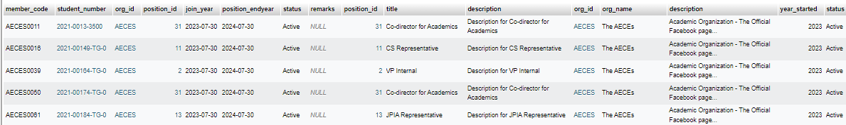

*Figure 14. Sample Inner Join*

**Nested Inner Join :**

| SELECT *  FROM tbl_membership  INNER JOIN tbl_positions ON tbl_membership.position_id = tbl_positions.position_id  INNER JOIN tbl_org ON tbl_membership.org_id = tbl_org.org_id; |
| --- |

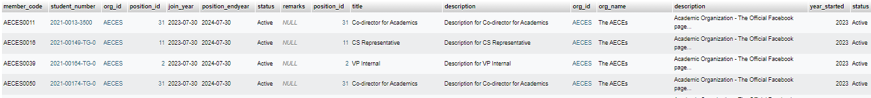

*Figure 15. Sample Nested Inner Join*

**Union :**

| SELECT event_id, title, event_date FROM tbl_events  UNION  SELECT announcement_id, title, posted_date FROM tbl_announcements; |
| --- |

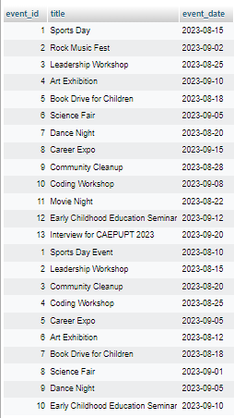

*Figure 16. Sample Union*

**Cross Join :**

| SELECT *  FROM tbl_studentinfo  CROSS JOIN tbl_org; |
| --- |

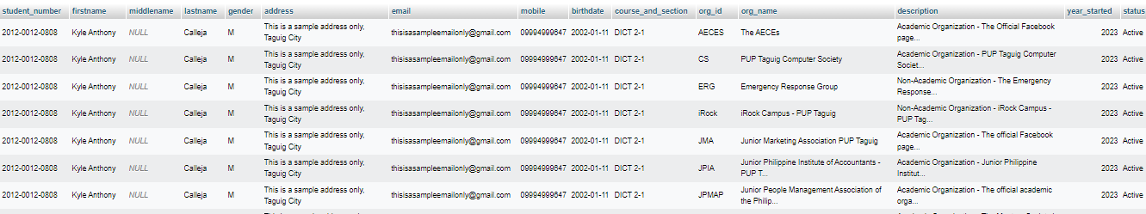

*Figure 17. Sample Cross Join*

**Right Outer Join :**

| SELECT *  FROM tbl_events  RIGHT OUTER JOIN tbl_org ON tbl_events.org_id = tbl_org.org_id; |
| --- |

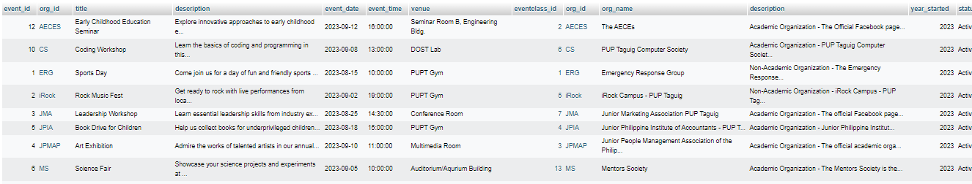

*Figure 18.Sample Right Outer Join*

**Full Outer Join :**

| SELECT *  FROM tbl_voters  LEFT JOIN tbl_candidates ON tbl_voters.voter_id = tbl_candidates.candidate_id  UNION  SELECT *  FROM tbl_voters  RIGHT JOIN tbl_candidates ON tbl_voters.voter_id = tbl_candidates.candidate_id; |
| --- |

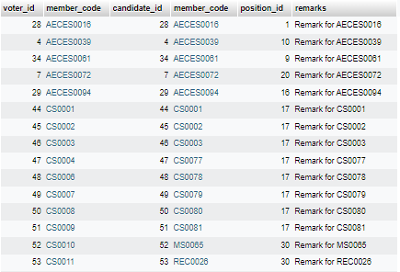

*Figure 19. Sample Full Outer Join*

**Full Anti Join :**

| SELECT *  FROM tbl_studentinfo  LEFT JOIN tbl_membership ON tbl_studentinfo.student_number = tbl_membership.student_number  WHERE tbl_membership.member_code IS NULL  UNION  SELECT *  FROM tbl_studentinfo  RIGHT JOIN tbl_membership ON tbl_studentinfo.student_number = tbl_membership.student_number  WHERE tbl_studentinfo.student_number IS NULL; |
| --- |



*Figure 20. Sample Full Anti Join*

**Left Outer Join :**

| SELECT *  FROM tbl_org  LEFT OUTER JOIN tbl_orgadviser ON tbl_org.org_id = tbl_orgadviser.org_id; |
| --- |

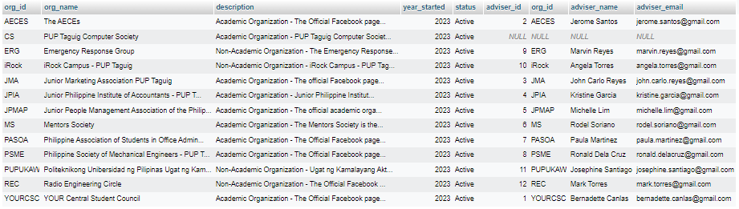

*Figure 21. Sample Left Outer Join*

**Right Anti Join :**

| SELECT *  FROM tbl_membership  RIGHT JOIN tbl_studentinfo ON tbl_membership.student_number = tbl_studentinfo.student_number  WHERE tbl_membership.member_code IS NULL; |
| --- |



*Figure 22. Sample Right Anti Join*

**Common Table Expressions :**

| WITH CandidateVotes AS (  SELECT  candidate_id,  COUNT(*) AS total_votes  FROM tbl_votes  GROUP BY candidate_id  ),  CandidateInfo AS (  SELECT  c.candidate_id,  c.remarks AS candidate_remarks,  m.member_code,  m.status AS member_status  FROM tbl_candidates c  JOIN tbl_membership m ON c.member_code = m.member_code  )  SELECT  ci.candidate_id,  ci.candidate_remarks,  ci.member_code,  ci.member_status,  cv.total_votes  FROM CandidateInfo ci  JOIN CandidateVotes cv ON ci.candidate_id = cv.candidate_id; |
| --- |

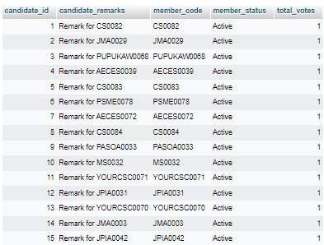

*Figure 23. Sample Common Table Expression*

**Self Join :**

| SELECT DISTINCT  m1.member_code AS member1,  m2.member_code AS member2,  m1.org_id,  m1.position_id  FROM tbl_membership m1  JOIN tbl_membership m2 ON m1.org_id = m2.org_id AND m1.position_id = m2.position_id  WHERE m1.member_code < m2.member_code; |
| --- |



*Figure 24. Sample Self Join*